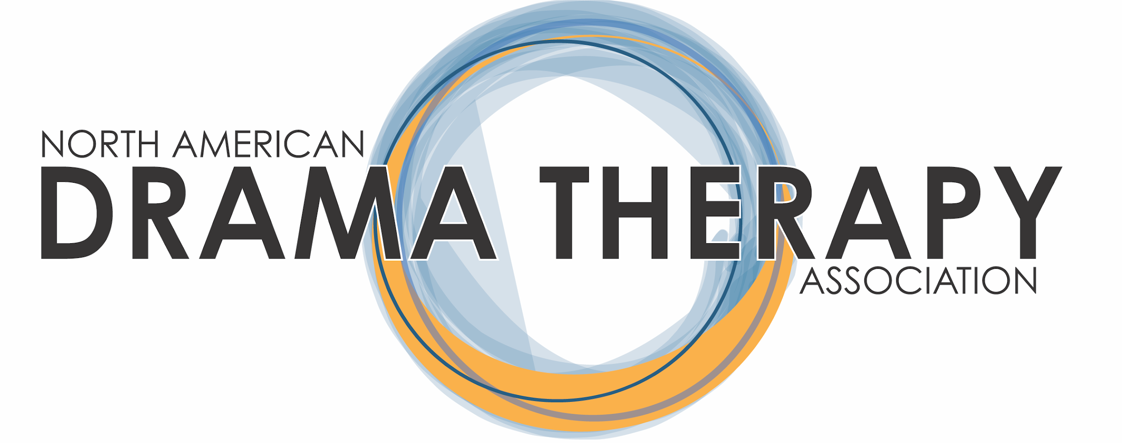

A MANUAL FOR

THE REGIONS OF THE NORTH AMERICAN DRAMA
THERAPY ASSOCIATION

Guidelines for Regional Representatives & Regional NADTA Groups

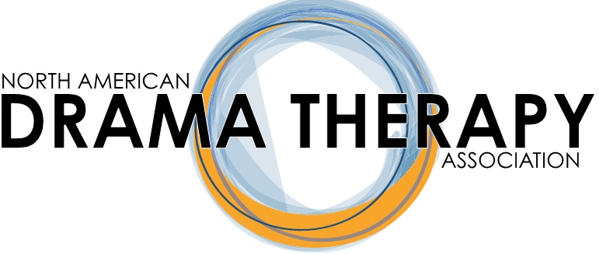

Table of Contents:

Part One: Revised Regional Model and Regional Representative Duties:

1.1 An Overview of Regional History
1.2 Duties of the NADTA Regional Representatives

Part Two: General Event Information for Regional Representative and NADTA Members:
2.1 General Information about Regional Events
2.2 Responsibilities of the Regional Reps in Selecting and Aiding Members Hosting Events
2.3 NADTA REGIONAL EVENT PROPOSAL/REQUEST
2.4 Example Promotion for Regional Events
2.5 Example Timeline to Follow for Member-Led Events
2.6 Example Timeline for a Regional Representative to Host a Regional Conference
2.7 Important Information About Events Providing CEs
2.8 Important Information about Petty Cash for Events

Part Three: Regional Ideas for Membership Connection
3.1 Overview of Regional Ideas Section
3.2 NADTA Canadian Region Information and Guidelines
a) Protocol For Parlour Talks
b) Canada: Protocol for Cross Canada ZOOM Calls
c) Establishing and maintaining relationships with students and recent graduates
d) Special Procedures or Considerations when Organizing the Canadian Regional Conference
e) Canada: A Step by Step Guide To Hosting a Workshop (Regional Rep and/or Regional NADTA Groups)
f) Canada: Regional Rep Overseeing Sub-committees
g) Canadian Membership Survey
h) Applying for CEU’s in Canada
i) Payment & Reimbursement of Expenses Incurred in Canadian Dollars
3.3 NADTA Central Region Information and Guidelines
a) Special Procedures or Considerations when Organizing the Central Regional Conference
b) Example Proposals and Event Forms
c) Zoom Meetings
d) Social Media and Interaction
e) Central Region Committee
3.4 NADTA Eastern Region Information and Guidelines
a) Special Procedures or Considerations when Organizing the Eastern Regional Conference
b) 2013 Eastern Region Conference
c) Social Media Presence
3.5 NADTA Western Region Information and Guidelines
a) Special Procedures or Considerations when Organizing the Western Regional Conference
a.1) Examples and Flyers of Western Regional Conferences
b) Presenter Series
b.1) Examples and Flyers of SoCal Presenter Series
c) Intro to Drama Therapy Public Workshops
d) The Nuts and Bolts of Creating Workshops: SoCal Dialogue
e) Template: Organizing the Planned Three-hour Workshop Day
f) Aiding Western NADTA Regional Groups
f.1) SoCal Regional NADTA Group:
f.2) The Pacific Northwest Regional NADTA Group:
Part Four: Forming a Member-Led Regional Group
4.1. (Adjusted) Guidelines for Creating Regional NADTA Groups and Activities
4.2 How to Figure Out If There Is Support for a Regional NADTA Group
4.3 Application Information to Form a Regional NADTA Group
a) Application to Form a Regional NADTA Group
b) REGIONAL NADTA GROUP NAME AND GOALS
c) Agreements and Signatures
4.4 Guidelines for Regional NADTA Meetings
4.5 Information for Groups to Create a Regional Event

Part Five: NADTA Regional Resources
5.1. NBCC CE Provider Policy Content Guide
5.2 NADTA Approved Provider Reference Sheet / NBCC and NYS LCAT Continuing Education Activities
5.3 NADTA LCAT/CE Request Form
5.3b NADTA CCPA/CE Request Form
5.4 Example Flyer and Program Requirements for Workshops Per NBCC Requirements
5.5 Example of Regional Event Program(excerpt) per NBCC Requirements.
5.6 Template of Evaluation Form For NBCC Approved Event
5.7 Template of CE Certificate per NBCC Approved Event
5.8 Liability Insurance
5.9 Template of Reimbursement Form for Payment from NADTA Office
ONLINE RESOURCES FOR PROMOTING YOUR REGION5.10

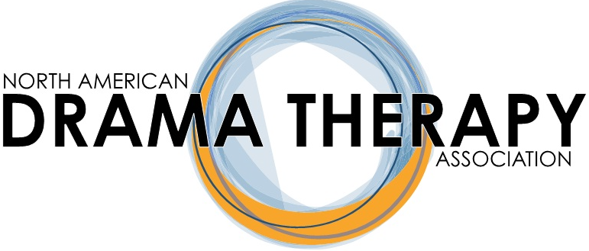

Part One: Revised Regional Model and Regional Representative Duties

North American Drama Therapy Association Regional Model to Envision, Organize, and Facilitate

An Overview of Regional History
The structural dynamics of our previous NADTA Chapter system required the NADTA board to make improvements via changes to our by-laws, which we believe will improve our function as an organization in a way that recognizes the unique needs of our regional communities.
Previously, our most active Chapters have struggled to avoid a revolving leadership model wherein the same community members come to occupy different roles in turn, calling into question the function of an overall Chapter’s role beyond that of fostering social connections in core hubs of drama therapists, such as Montreal, LA, and NYC.
To honor the member-focused culture that characterizes the NADTA, your Regional Representatives and Membership Chair have replaced the chapter model with a regional model that reflects our diverse North American community, spanning the geographical breadth and specific professional needs of our membership.
Our Common Goals: While fostering connection and collegiality will remain central goals of regional events, we also hope to generate opportunities for increased leadership amongst individuals in their regions as members are invited to envision, organize, and facilitate events for fellow drama therapists and allied professionals.

For purposes of “event” definition, events may be in the form of workshops, conferences, symposiums, lectures, trainings, parlour talks, or online training. Not all events must provide CEs; however, must be proven to be a benefit to the NADTA community.

As decided by the 2017-2019 Board, each Regional Representative will be provided $7000 each fiscal year. $5000 will be available to members submitting proposals for local/regional events during the fiscal year. Proposals will be accepted twice per year and event funds will be allotted for approved proposals at the Regional Representative’s discretion with assistance from a proposal committee. More information about regional events will be found in Part Two of the manual.

In addition, $2000 will be available to the Regional Representative each fiscal year for purposes of hosting NADTA events and NADTA membership networking.

Overview of Regional Representative Duties: Using this model, Regional Representatives will support members by providing a framework on which to build community events. Examples include:
- provide seed money for member hosted workshops/mini conferences to
interested and motivated regional members
- offer social media support
- email blast to the entire region
- quarterly calls that keep the pulse of the community at large
- serve as conduit to Education chair for acquisition of CEs
- Provide information to region by writing in Behind the Scenes

Overview of Finances: With the shift from a chapter to regional model of member engagement, chapter dues will be replaced by regional dues. The amount will be comparable.
- Provide finances for selected workshops and training events on site or online, each with a particular focus on topic, theory or technique that can be approved by the CE affiliate such as the NBCC.
- Per specific, democratic and ethical criteria, Regional Reps will decide how to designate funding for events in their region if interested and motivated NADTA members request it. As well, the Regional Rep can act as Chair or Co-Chair of regional events that do not coincide with the national conference.
Adjustment about Regional Events: NADTA members from specific regions inclusive of cities and states who are interested in staging an event will be invited to apply to their Regional Representative for financial support, in the form of a seed money proposal. The intention is that events would take place in different geographical areas of each region, honoring the diverse ways in which drama therapists learn and commune within North America.
Events (online or onsite): Events will be produced by and open to all NADTA members. They will welcome other professions (i.e. Expressive Arts Therapists, Social Workers, Marriage and Family Therapists) interested in collaboration, CE’s, or community support. Primarily regional events will support regional connections and identity within our collective field. Our members will be encouraged to step up and engage one another in ways that make them innovate and grow as therapists.
Regional Groups/Communities: Individuals can generate NADTA membership through their common interests and intent to produce events through their membership with NADTA. They can contact their Regional Representative and complete a signature page that designates their regional location, initiating group members and intent (Signature page included in manual). This serves as a promissory that the regional group will adhere and uphold NADTA ethical standards and follow NADTA manualized guidelines as they represent the national organization.
- Titles of Regional Groups/Communities: Per the enclosed documents in this manual, regional groups sponsored by NADTA are called Regional NADTA Groups. Previously designated NADTA Chapters are defunct. Instead, previous chapters can now have such titles as: SoCal Regional NADTA Group, Pacific Northwest Regional NADTA Group, Colorado Regional NADTA Group, Tri-State Regional NADTA Group, Texas Regional NADTA Group, Midwest Regional NADTA Group. Per their decision, they may narrow their identity to a specific city or grouping such as New York Regional NADTA Group, San Francisco Regional NADTA Group, Montreal Regional NADTA Group, or DvT Portland Regional NADTA Group, Kansas City Regional NADTA Group, Minneapolis Regional NADTA Group, etc.
AT Students and their Affiliation with Regions: AT students will be able to capitalize on increased opportunities to learn and train within the regions in which they live, widening their net of experience as practitioners. Ideally, the Regional Rep will provide an annual forum or way for new students to meet and greet onsite or online.

Duties of the NADTA Regional Representatives
- Serve on the NADTA Board of Directors and attend bi-annual meetings, as well as other board related activities
- Provide liaison between regions and NADTA Board
- Network with NADTA members (and non-members) through mail, phone, fax, email, and conference calling
- Serve as an information exchange/people connector in their region by providing conferences, meetings, etc.
- Coordinate with the Student Representatives from Drama Therapy programs in their region and/or Alternative Training institutes/sites
- Support, help develop, and/or revitalize Regional NADTA Groups.
- Assist the Membership Chair in recruiting and retaining members within a region
- Lead regional meeting during the annual conference to connect with members of the region
- Report activities and pertinent/essential information and news in Behind the Scenes
- Liaison to local/state political concerns and legislative actions; report directly to Government Affairs Chair and President

Member-At-Large/Regional Representative Criteria

- Eligibility: A Member-At-Large (Regional Representative) must be a member of NADTA in good standing and an RDT.

- Currently there are four Members-At-Large elected to the NADTA Board by the membership in their region: Eastern, Central, Western, and Canadian.

  - The Eastern Region covers the following states: Connecticut, Delaware, District of Columbia, Florida, Georgia, Maine, Maryland, Massachusetts, New Hampshire, New Jersey, New York, North Carolina, Pennsylvania, Rhode Island, South Carolina, Vermont, Virginia, West Virginia. [AD1]

  - The Central Region covers the following states: Alabama, Arkansas, Illinois, Indiana, Iowa, Kansas, Kentucky, Louisiana, Michigan, Minnesota, Mississippi, Missouri, Nebraska, North Dakota, Ohio, Oklahoma, South Dakota, Tennessee, Texas, Wisconsin[AD2] .

  - The Western Region covers the following states: Alaska, Arizona, California, Colorado, Hawaii, Idaho, Montana, Nevada, New Mexico, Oregon, Utah, Washington, Wyoming.

  - The Canadian Region covers all ten provinces and three territories in Canada.

- Terms and Election: A Member-At-Large must live in the region he or she represents.. Members-At-Large can serve no longer than 2 consecutive two-year terms in the position.

- Board Membership: NADTA bylaws state that Members-At-Large “shall provide liaison between those regions and the Board of Directors. They shall also serve on the Board of Directors and Board committees as needed.”

- Members-At-Large should consider themselves members of the Membership Committee since they represent the membership of their regions.

Specific Duties of Members-At-Large/Regional Representatives

1. Attend two Board meetings each year (Spring meeting at location to be determined and Fall meeting at the annual conference) and submit a written report to the Board of tasks accomplished prior to each meeting.

2. Participate in conference call meetings as scheduled by the President.

3. Serve as point of entry to the membership - to encourage newcomers and students to join and to receive input of the membership in their regions to take back to the Board. Make an effort to welcome all conference attendees, all new students and new or potential members in the region via mail, phone, fax, email, and/or conference calls[AD3] . Encourage collegiality and connection in the region.

4. Serve as an information exchange/people connector in their region to provide information about membership in NADTA as well as drama therapy in general to members and potential members in your region.

The Member-At-Large can encourage drama therapists to communicate, mentor, and share with one another within the region, as well as bring people together from other professions for workshops and other opportunities to exchange knowledge and experience in an attempt to offer support within the profession.

5. Coordinate with the Student Representatives from Drama Therapy programs in their region and/or Alternative Training schools/sites to provide an annual membership recruiting meeting for new students. Membership and Drama Therapy information brochures can be requested for free from the NADTA National Office. The Membership Chair is the official liaison with the Student committee and can provide contact information (See Job Description of Student Representatives for more information).

Board Certified Trainers across the country may run alternative training sites or work independently with alternative training students. Check with them to see if they would like a membership meeting or if you can serve their needs in some other way. (See the current list of Board Certified Trainers for more potential alternative training sites)
- Eastern Region Member-At-Large should coordinate with Student Representatives for NYU, Lesley, Marymount Manhattan and any other training programs in the region inclusive of AT schools.
- Western Region Member-At-Large should coordinate with the Student Representatives at CIIS, Antioch Seattle and any other programs in the region inclusive of AT schools.
- Canadian Member-At-Large should coordinate with the Student Representatives at Concordia and any programs in the region inclusive of AT schools.
- Central Region Member-At-Large should coordinate with Student Representatives for Kansas State and any other programs in the region inclusive of AT schools.

6. Coordinate with existing regional NADTA groups and assist with the development of new groups within the region.
- Ensure the local groups have a copy of current NADTA group procedures and responsibilities (provided in this manual).
- Assist Regional NADTA Groups in connecting with resources available from the national organization. (Particularly for conferences).
- Ensure that the regional group leadership knows how to look up Regional Group NADTA membership lists.
- Send emails (or coordinate for the office to send them) to members of the Regional Group or people in the appropriate area. (Note that Board members have access to send group emails to members, but members do not have this access.)
- Visit local Regional Groups when possible.
- Keep the Board up-to-date with Regional Group developments – as the NADTA Board is liable for activity, contracts and financial decisions made in NADTA’s name.
*Note: To secure consistent communication, the Regional NADTA Groups should email their Regional Representative first with questions. If following up on the minutes of meetings, they can email the Regional Rep and then CC President, President elect and the NADTA office.

- Provide developing regional groups information and assistance via our manualized directions– which includes a signature page of intent with a member’s list, in order to form a NADTA supported Regional NADTA Group (included in manual).
- Report to the Membership Chair, President and office by January 30thof each year if there are Regional NADTA Groups that need to be added or removed from the membership form.

7. Write a report in Behind the Scenes about activities and pertinent/essential information within the region.

8. Assist the Membership Chair with the member spotlight and with retention and recruitment of members in your region.

9. Lead regional meeting at the annual national conferences and to assist with other board activities during these national conferences.

10. Stay current with the NADTA website and report any problems with content to the NADTA office, President, and President-Elect.

11.Budget and Finance: All board members of a C-Corporation are responsible for managing the financial health of the organization and for ensuring the ethical use of funds. Review the annual budget and provide input regarding membership needs and appropriateness of expenditures. Assist with oversight for Regional NADTA Group budgets and Regional Conference budgets. Provide support and coaching for Regional NADTA Groups and Regional Conference Chairs about options to help reduce expenses and increase income. Review income and expenditures for accuracy.

12. Liaison to local/state political concerns and legislative actions; report directly to Government Affairs Chair and President.

13. Perform any relevant tasks/duties assigned by the NADTA Board of Directors.

Part Two: General Event Information for Regional Representative and NADTA Members

General Information about Regional Events

While fostering connection and collegiality will remain central goals of regional events, we hope to generate opportunities for increased leadership amongst individuals in their regions as members are invited to envision, organize, and facilitate events for fellow drama therapists and allied professionals.

For purposes of “event” definition, events may be in the form of workshops, conferences, symposiums, lectures, trainings, parlour talks, or online training. Not all events must provide CEs; however, must be proven to be a benefit to the NADTA community.

As decided by the 2017-2019 Board, each Regional Representative will be provided $7000 each fiscal year. $5000 will be available to members submitting proposals for local/regional events during the fiscal year. Proposals will be accepted twice per year and event funds will be allotted for approved proposals at the Regional Representative’s discretion with assistance from a proposal committee. In addition, $2000 will be available to the Regional Representative each fiscal year for purposes of hosting NADTA events and NADTA membership networking. Due to special regional considerations, Regional Rep hosted conference guidelines and timelines will be covered under each specific Regional sections of this manual.

In this portion of the manual, the following items will be covered:

- Responsibilities of the Regional Reps in selecting and aiding members hosting events
- Example proposal/budget for members to complete and submit
- Example Promotion for Regional Events
- Example timeline to follow for member-led events
- Example timeline for a Regional Representative hosted Regional Conference
- Important information about events providing CEs
- Important information about petty cash for events

Responsibilities of the Regional Reps in Selecting and Aiding Members Hosting Events

Regional Representatives will be responsible for the following actions concerning member-hosted events:

- Encourage and advertise opportunities to regional members throughout the year with information about proposal deadlines.
- Provide proposals for interested members.
- Work with the Vice-President and national Conference Chairs concerning proposals that were not chosen for the national conference.
- Determine deadlines for proposals - Regional Reps will work together to determine two deadlines per year that will not interfere with the national conference in the fall.
  - During the initial Regional Model year (2020), suggested proposal deadlines would be:
    - February 1 for events running from March15 – August 15
    - July 1 for events running from August 16 – December 31
  - During subsequent years (for events during 2021 – on), suggested proposal deadlines would be:
    - December 1 for January – June events
    - June 1 for July – December events
- Even though there will be two set deadlines for proposals, please note that Regional Reps may still accept smaller requests for funding (if the full amount of allocation money is not used for each deadline).
  - Please review below concerning the suggested allocation of funds for each deadline within a year.
- Review proposals, with the assistance of other Regional Reps and Executive Board (if needed) to accept events. Prompt review and acceptance of proposals will be essential to provide members, hosting events soon after the deadline, ample time to plan their events. It is recommended to make proposal decisions less than 2 weeks after the proposal deadline.
  - Event proposals requesting under $2000 in monetary aid may be determined by the Regional Rep committee.
  - Event proposals requesting over $2000 in monetary aid should include the Executive Board in determining acceptance of proposal.
- Determine the allocation of $5000 designated per year for member-led events, being conscious of diversity and inclusiveness of locations and populations.
  - It is suggested to split the $5000 in half to provide funding for both deadlines within the year ($2500 for first deadline/ $2500 for second deadline)
  - Any unused funding per deadline can be used to accept smaller requests after each deadline.
- Work with the Treasurer to provide monetary assistance for approved events.
- Offer assistance to members planning events in the way of:
  - Email Blasts to the entire region
  - Social Media posts
  - Behind the Scenes write up
  - Posting on NADTA website “Upcoming Events” section
  - Working with the NADTA office to create Registration for Event on the NADTA website
  - Answering questions or concerns of members planning event
  - Working with Education Chair in providing CEs (if applicable)
- If possible, the Regional Rep will attend the event to offer support.
- Request a write a review/follow up about the event from the member(s) and provide to regional members via email and social media.
- Work with the event planners and Treasurer that funds from the event have been returned to the regional “pot” for future usage.

I. NADTA REGIONAL EVENT PROPOSAL/REQUEST

Complete these three sections of the event and budget proposal, required to request funds.

1. Date of Proposal:

2. Name of individual/coordinator filling out proposal:

3. Co-Sponsorship person or institution:

4. Title of Event:

5. Day and Date of Event:

6. Event Location(please be specific with location):

7. Event Time:

8. Number of attendees anticipated:

9. Name and Contact information(phone number and email address for each member of the planning committee) Please add members, if needed.
· Main Contact/Coordinator:

· Member:

· Member:

· Member:

10. Focus – In 50-100 words,please describe the focus of the event and the benefits to attendees.

11. Offering CE’s? __________________________________________________________

12. List Event Objectives acceptable by NBCC standards (see NBCC guidebook referenced in Regional Manual if needed):

13. Presenter Credentials – For each presenter, please provide information about their credentials and what they will discuss/present during their workshop. Workshops can be comprised of panel and co-presenters, etc. Feel free to add info on another sheet.

· Keynote Speaker (if having):

· Speaker 1:

· Speaker 2:

· Speaker 3:

· Speaker 4:

14. Monetary Considerations– Grants will be awarded depending on various criteria administered by your regional representative with board approval. Request only what you need for planning the workshop/symposium/event-- large or small. The event organizer may be granted a $100.00 personal stipend for coordinating everything.

15. Expenses: Grants should be utilized for rental space, insurance of the space, compensation for presenters, promotions, copying, refreshments and travel stipends for local presenters. Not all presenters require payment for events. Maximum 30% of the grant may be used for those who want compensation. In addition, please ensure to save all invoices and receipts during your planning. After the event, please submit these items with the reimbursement sheet provided in the regional manual via email to your regional rep and the NADTA office and/or send materials to:

NADTA Office, 230 Washington Avenue Extension, Suite 101
Albany, New York 12203

II. REGIONAL EVENT BUDGET PROPOSAL/REQUEST
Please follow regional manual guidelines when filling out the budget proposal so that regional representatives can best expedite your needs as they consider your requests. In this next step, you, the event coordinator(s) will have gathered information about event aims, itinerary, facility costs, other event costs and perhaps reserved the facility. Fill out this event request/proposal form before making any deposits. Email form to regional rep and NADTA office.

A. Are you requesting money for an NADTA sponsored regional event?_______________

B. If so, then when do you need the funds? Please provide date: _____________________
1. Will you be requesting payment direct to the source (facility, vendor) from the NADTA office? By credit card (allow 72 hours) Item(s): _____________________
2. Contact & info for payment: _______________________________________________________________________

3. Date due_____________*

C. For Review and Approval. Please submit copy of sample/unsigned site contract/invoice to regional rep and NADTA office. Board officers will review requests.
4. Will you be requesting payment direct to the source (facility, vendor) from the NADTA office? By check (allow 3 weeks) Item(s): ____________________________

5. Contact & info for payment:
_____________________________________________________________________
6. Date due______________*

D. For Review and Approval. Please submit copy of other sample/unsigned contracts/invoices needed for event to regional rep and NADTA office. Board officers will review requests.

Total Budget for Event: _______________________________________________
Please submit budget with request for funding. Per Regional Manual suggestions, recruit volunteers for all aspects of proposed event as necessary to alleviate budget costs and involve community. Meet with necessary parties to discuss any needed changes in room configuration, rules regarding facility usage, provision of A/V equipment, table, chairs, or contract deposits, refunds and clean-up. Please note, you will be responsible for the event but the NADTA will be represented by your actions and the event which will serve the community.
Use the Regional Manual as your guide to coordinate your itinerary and event day. Submit final receipts for reimbursements once accepted (expect 2-4 weeks processing). Once you have been budgeted.
Enjoy the process and your accomplishments! Document your event through social media!

III. REGIONAL EVENT BUDGET WORKSHEET
Please fill out the budget proposal worksheets as part of your event proposal and request for funds and send to your regional rep and NADTA office for review.
1. INCOME
Budget Actual Source
$ $ NADTA (Funds via the Regional Rep)
$ $ Co-Sponsorships______
$ $ Registrations_________
$ $ Other (i.e program ads or event table ad sales)
TOTAL INCOME:

2. ONSITE/PROGRAM EXPENSES

Budget Actual Source

$ $ Contracted Presenters (fee?)

$ $ Travel (stipend to presenters)

$ $ Food/beverages

$ $ Activity Supplies______

$ $ Prizes (door raffle); presenter gift

$ $ Other ($100.00 stipend for organizer)

TOTAL FOR ONSITE PROGRAM:

3. OPERATIONS/PRODUCTION EXPENSES

Budget Actual Source

$ $ Facility Rental

$ $ A/V Equipment (sound, projector)

$ $ Other Rentals/Equipment (screen, podium, etc)

$ $ Tech Support/Staff/Security (if required)

$ $ Decorations (8-10 ft. tablecloths/ rental/ posters)

$ $ Same day Event Insurance (info Region manual)

$ $ Other

TOTAL PRODUCTION:

4. PUBLICITY

Budget Actual Source

$ $ Flyers/Posters

$ $ Tables (8-10 ft tables; Podium & Chairs

$ $ Banners, tabletop ads, direction/NADTA logo signage

$ $ Other print costs (flyers, programs, sign-ins, evals)

$ $ Ads/Publicity

$ $ Other (volunteers, assistance)

TOTAL FOR PUBLICITY:

Example Promotion for Regional Events
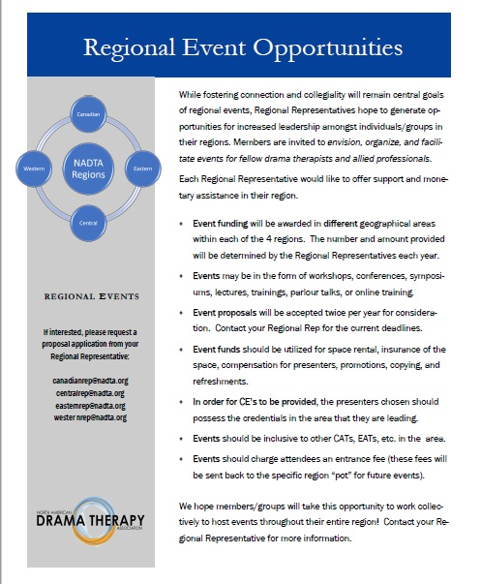

Example Timeline to Follow for Member-Led Events

The following timeline is a guideline for members hosting regional events:

- Important to Note - Regional events should not interfere or compete with the NADTA National Conference in the fall. In addition, different regions might have special considerations (i.e. Canadian exchange rates). It is important to ask your Regional Rep of these considerations.

- General Planning Timeline - While this timeline will be change for each event (based on the time between proposal acceptance and day of event), it will be important to complete tasks as soon as possible to ensure proper planning, monetary aid, and increased attendance at the event.
    - Determine when and where the event will be held. Ensure to receive accurate costs of venue, liability insurance, etc. prior to filling out a proposal.
    - Assemble a committee to help with planning and executing the event. It is a good idea to solicit the help of individuals who live at or close to the city/town you are planning your event. You can receive a list of current members and their locations from the office or Regional Rep.
    - Request and complete event proposal/budget by the deadline set by Regional Reps. Ensure to provide a request of petty cash needed for purposes of planning the event (part of proposal). Be certain to read important information concerning petty cash (found later in this part of the manual).
    - If selected, begin working with event committee, Regional Rep, and Treasurer to pay for venue and theme.
    - Work with the Education Chair and Continuing Education Committee, if providing CEs for event. Be certain to read important information concerning CEs (found later in this part of the manual).
    - Work with the NADTA office to prepare and set up the online registration information (for NADTA members and non-members) and promotion information to be posted through the NADTA website. The office will help to add the event information and all links to the main page.
    - Work with the Regional Rep to promote event. Members hosting the event are responsible for all wording and visuals connected to the event. Ensure to provide the Regional Rep with event information as soon as possible to promote the event via email and social media. Inform the Regional Rep of a schedule of promotions (event, registration, reminders, etc.) and provide any changes that should be made during the promotion process.
    - Compile a list of local allied professionals, colleges, etc. and send out an invitation to distribute information and attend the event.
    - Work with the NADTA office in determining how to take payments at the door. The office might have equipment that you are able to use; however, advance notice is required.
    - It is recommended to get insurance coverage for your venue (just in case something happens). Insurance coverage information is covered within this manual.
    - Begin working on the program order for the event. Determine any technology needs and work with the venue to determine if these can be met or if the committee will have to provide these items. Send out the program draft to committee for review.
    - Open up registration for members and other interested parties. Work with the Regional Rep to send out emails and posts to social media..
    - Create a list of items needed for the event, including banners (contact the office for a NADTA banner, if wanted), items for the attendees (folders, paper, NADTA pens [ask office], programs, other information to be placed in folders, name tags, etc.), snacks and drinks to be provided, etc. Ask planning committee with assistance in gathering some of the items.
    - Send the finalized event information to the NADTA office (to add to the event information on the website), the person of contact for the venue, and planning committee.
    - Send out an email to planning committee about tasks that will have to be completed prior to event.
    - Ask a member of the planning committee to go to the venue to look at the space (if you are unable to) and report back on the size of rooms, equipment information, and other important information. Provide contact information for the venue to this member.
    - Work with the planning committee to determine jobs at the event.
    - Ask the Regional Rep to send out a last reminder to members about registration via email and social media.
    - One week and two days prior to the event, request a current list of attendees from the NADTA office.
    - Prepare Letter of Attendance and/or CE forms (if providing for event) that will be provided to attendees at the end of the event.
    - It is recommended to determine when you are able to set up for the event. If possible, see if you can set things up the evening before the event begins.
    - Coordinate with planning committee members on their tasks.
    - Enjoy!
    - After event, complete the following tasks:
      - Clean venue
      - Ensure venue/vendors have received payment
      - Coordinate a meeting with planning committee to review event
      - Create a comprehensive write-up to submit to the Regional Rep to keep for region records. Provide a condensed write-up that the Regional Rep may distribute to the community at large
      - Submit any final receipts for reimbursement (may take 2-4 weeks to process payment)
      - Send out thank you notes to individuals involved in planning, presentors, vendors, volunteers, etc.

Example Timeline for a Regional Representative to Host a Regional Conference

- Rationale - A Regional Representative may choose to host a regional conference during the spring (sometime between March and June). The reasoning behind this is to ensure that regional conferences do not interfere or compete with the NADTA National Conference in the fall. Below is the recommended timeline in creating a regional conference.
- Early Planning
  - Late August/Early September – Determine when and where the conference will be held. The Regional Rep might decide on their own (choose something close to where they live) or send out a questionnaire to region members in order to receive their input and ideas. It is a good idea to change the location each year (if possible) and to ensure that this movement ensures that members of north, south, east, and west sections of the region are represented. However, the Regional Rep should also consider ease of transportation for the members and cost of venue. In determining cost of venue, keep in mind that each region has $2000 allocated for Regional Rep led events. If the venue you are booking requires payment, submit a proposal with estimated costs of the conference as soon as possible to the Treasurer.
  - September/October – Begin to assemble a committee to help in planning and executing the conference. It is a good idea to solicit the help of individuals who live at or close to the city/town you are planning your conference. You can receive a list of current members and their locations from the office. This committee can help to decide on the theme of the conference, help to review the proposals, and help with final preparations for the venue.
- Four months before the conference - The rest of the timeline is dependent on when (month) you have the conference.
  - Send out a call for Proposals via email and social media. In this proposal, provide information about the theme/purpose of the conference, pricing and discount information, and proposal form. The Regional Rep can request that proposals be sent back via email or by completing an online form such as a Google Form (this way will provide easy viewing for the conference planning committee). Set the due date for at least two months before the conference.
  - Depending on where you are having your conference, you might personally invite certain members to submit a proposal. Work with NADTA Conference team and office to pull from unaccepted proposals to the national conference.
  - Work with the NADTA office to prepare and set up the online registration information and promotion information to be posted through the NADTA website. The office will help to add the conference information and all links to the main page. While this information will not be posted to the website until a future time, completing this task early on will provide time to work out any problems and provide the office ample time to complete all changes and actions necessary.
  - Work with the NADTA office to receive a presenter discount code (this will be needed when you send out presenter acceptance letters). Also, determine how scholarships can be handled (if providing for conference). Finally, ask the office if they have a way for you to take debit or credit card payments at the door. The office might have equipment that you are able to use.
  - It is recommended to get insurance coverage for your venue (just in case something happens). Insurance coverage is covered later in this manual.
  - Determine cost of conference - This will be dependent on region. In the past, the Canadian and Central Regions have set registration fees at approximately $50-$60).
  - Work with the Education Chair and Education Committee, if wanting to provide CEs for conference attendance.
- Two and a half months before the conference
  - Release promotional information to region members via the NADTA website, email, and social media. Make sure to include information about scholarships (if you are providing any) within this letter. For example, scholarships awarded might include Presenter-Member, Presenter-Student, Non-Presenter-Member, and Non-Presenter-Student. Determine if you want scholarships to be submitted via email or online. Set the scholarship deadline to be TWO weeks Set the registration deadline to be ONE week before the conference.
  - Send out a reminder to region members about the proposal due date.
- Two months before the conference
  - Review the proposals with planning committee. Review the proposals for matching topic to theme of conference and for duplicate proposals (if more than one person is submitting the same topic).
  - After the acceptance of proposals, send out a letter to each proposal submitter to inform them if their submission has been accepted or denied. If their submission has been accepted, provide them with the presenter discount code. If they have been denied, provide the reasoning for the denial.
  - Begin working on the program order for the conference. Determine if you will have breakout sessions or a full conference session. If a presenter needs technology for their presentation, work with the venue to determine these needs. Send out the program draft to presenters and committee for review (make sure to set a two week review deadline).
  - Open up registration for members. Send out and email and post to social media about registration.
  - Create a list of items needed for the conference, including banners (contact the office for a NADTA banner, if wanted), items for the attendees (folders, paper, NADTA pens [ask office], programs, other information to be placed in folders, name tags, etc.), snacks and drinks to be provided, etc. Ask planning committee with assistance in gathering some of the items (this will be helpful if you have to travel to your destination).
- One month before the conference
  - Send out a reminder to region members about scholarship and registration deadlines.
  - Begin compiling items for folders, name tags, etc.
  - Send the finalized program order to the NADTA office (to add to the event information on the website), the person of contact for the venue, and planning committee.
  - Send out an email to planning committee about tasks that will have to be completed in a few weeks’ time (scholarship review, gathering supplies, etc).
  - Ask a member of the planning committee to go to the venue to look at the space (if you are unable to) and report back on the size of rooms, equipment information, and other important information. Provide contact information for the venue to this member.
- Two weeks before the conference
  - Work with the planning committee to review scholarships. If you do not receive a submission in a category then that scholarship is not given out. This review will have to be a quick turnaround due to the registration deadline.
  - Work with the planning committee to determine jobs at the conference and who will be in charge of gathering supplies (snacks and drinks).
  - Send out a last reminder to members about registration via email and social media.
- One week before the conference
  - Check in with venue.
  - Request a current list of attendees from the NADTA office.
  - Create name tags and prep Letter of Attendance that will be provided to attendees at the end of the conference.
- Conference Time!
  - It is recommended to work out when you are able to set up for the conference. If possible, see if you can set things up the evening before or a few hours before the conference begins.
  - Coordinate with planning committee members on their tasks.
  - Enjoy!
- Post Conference Actions
  - Create a post-conference evaluation survey (i.e. Survey Planet, Survey Monkey, or Google forms) and send out to all conference attendees. The Regional Rep will create a complete summary of the survey findings and shares with the conference planning committee in a wrap up meeting two months after the conference.
  - Fill out NADTA Reimbursement Form and submit to the NADTA office together with all receipts, if needed.
  - Create a brief write up to disburse to regional members via email, social media, and Behind the Scenes.

Again, remember to check the Regional Section of this manual for specific concerns and considerations for your region. In addition, if possible connect with past Regional Reps with any questions or concerns while planning the regional conference.

Important Information About Events Providing CEs

If CEs will be provided at an event, please review the following information carefully to ensure proper protocol is followed:

Continuing Education Activities Policy 1.0
Date Ratified by Board: [XXXX]
Revised: October 2019

Introduction (Why is this policy necessary)
The NADTA has established status as a provider of Continuing Education activities with the National Board for Certified Counselors (NBCC) and the NY State Department of Education (NYSED), which allows the organization to develop and conduct continuing education activities for individuals whose licenses or certifications governed by those entities. The largest CE-granting activity conducted by the NADTA is our National Conference, but continuing education activities can be conducted by regions, regional NADTA groups, and committees.

Objective(s): (What does this policy seek to accomplish)
This policy is designed to ensure that the NADTA produces continuing education activities in accord with the highest ethical and educational standards and in a manner that fulfils all requirements of the appropriate regulatory bodies and in the service of our members.

Scope: (What are the limits of this policy)
This policy applies to continuing education activities designed and implemented by the NADTA, or by NADTA regions, regional NADTA groups, or committees that seek to use the NADTA agreements with NBCC or NYSED to provide qualifying CE activities for individuals who hold licenses governed by those entities.

Policy: (directives)
1. The NADTA (In the form of the yearly national conference), regional NADTA groups, NADTA regions, and NADTA committees, can produce continuing education activities.
2. Individual members of the NADTA cannot produce continuing education activities under this policy, the activities must be co-sponsored by one of the above entities.
3. The Continuing Education committee will assist in the creation of CE activities and determine if a proposed activity meets the requirements for NBCC or NYSED approval (or both).
4. Groups/Individuals generating continuing education activities will coordinate with the NADTA office to deliver the necessarily documentation for storage and archival. Regional groups/Members hosting events will coordinate with their Regional Representative who will assist in this process by also storing CE documentation.

Procedures (execution of directives/who/when/etc.)
The Continuing Education Committee is a subcommittee of the Education Committee and is chaired by the Education Chair.

Membership on CE Committee: Because of the importance of the National Conference the Program Chair of the Conference Committee is considered a standing member of the CE committee.
1. Regional Groups/Members that wish to conduct CE-granting activities should work with the NADTA Regional Representative who will join the CE committee.
2. Regions that wish to develop and conduct CE-granting activities will coordinate with their Regional Representative and nominate a representative (who will be onsite for the event) to the CE committee.
3. NADTA Committees that might wish to develop and conduct CE-granting activities (such as the Diversity or Government Affairs committee) will coordinate with their Chairperson and nominate a representative to the CE committee.

Procedures: Groups/Members wishing to develop and conduct CE-granting activities will submit their proposals to the Chair of the CE Committee who will assign them to committee member(s) for review. Regional groups/members will go through their Regional Rep for the CE-granting process, as well ( forms and criteria are provided in this manual)
1. Submissions received fewer than 30 days in advance of a proposed activity may not be approved in time for event attendees to receive credit for CEs
2. CE committee reviewers will evaluate proposals according to the criteria of the regulatory agencies as well as according to the ethical code of the NADTA
3. After review, the CE committee member will inform the sponsoring group/member either of the activity’s approval or rejection for the desired CE’s. When possible, the committee member will offer suggestions as to how the CE proposal could be revised to comply with requirements.
4. On final approval, the CE committee will inform the NADTA office of the approved CE activity.
5. The NADTA office may develop additional requirements related to the documentation and storage of attendance-related information regarding CE activities.

See Resource section of manual for forms and examples per NBCC guidelines.

Important Information about Petty Cash for Events

If petty cash is needed for purposes of planning an event, please review the following information carefully to ensure proper protocol is followed:

Title: Treasury Policy 2.0
Date Ratified by Board: 11/23/2013
Revised:

Introduction:

Objective(s): This policy makes small amounts of cash available to Regions for immediate use for
costs incurred directly for regional events and activities and in the service of the NADTA mission.

Scope: Applies to regional events approved for petty cash by the NADTA Board.

Policy: Regional Representatives must submit a balanced annual budget in advance, and this budget
must be approved by the NADTA Board of Directors. For the concerns of various Regional
Groups/Members and their funded activities that will garner or expend income, Regional Reps must
submit income and expense reports on a regular basis as requested by the NADTA Board Treasurer.

Procedures:

1. All income received by the particular Regional Rep and Regional event will be deposited into an NADTA bank account and be designated for that particular region’s use.
2. The Regional Rep or member hosting event will be given an agreed upon petty cash amount – up to but not exceeding $250.00 and not exceeding the amount of funds available in the regional account or spreadsheet balance. When that amount is used (or close to being used) the Regional Rep and/or member will forward receipts to the NADTA treasurer.
3. The NADTA Treasurer will review the receipts and if all is in order, will replenish the petty cash fund to the agreed upon amount.

Part Three: Regional Ideas for Membership Connection

Overview of Regional Ideas Section

Within this section of the manual, current Regional Reps will find ideas from past Regional Reps concerning membership connection possibilities and special considerations within each region:

In this portion of the manual, the following items will be covered:

- Canadian Region Ideas and Special Considerations
- Central Region Ideas and Special Considerations
- Eastern Region Ideas and Special Considerations
- Western Region Ideas and Special Considerations

It should be noted that even though this section is broken up into regions, a Regional Rep may pull from any of the ideas provided under all regional sections.

NADTA Canadian Region Information and Guidelines

- Protocol for Parlour Talks
- Protocol for Cross-Canada Zoom Calls
- Establishing and Maintaining Relationships with Students and Recent Graduates
- Special Procedures or Considerations when Organizing the Canadian Regional Conference
- A Step by Step Guide to Hosting a Workshop
- Overseeing Sub-Committees
- Canadian Membership Survey
- Applying for CEU’s in Canada
- Payment & Reimbursement of Expenses Incurred in Canadian Dollars

Protocol For Parlour Talks
Parlour Talks was an incentive created by the Canadian Regional Representative in 2016, in response to many individuals across the country voicing that they were feeling isolated, lonely and far away from the hub of Montreal, Quebec, where the greatest concentration of Drama Therapists reside in Canada. The intention was to form provincial groups primarily for Drama Therapists but open to those interested in Drama Therapy, including other Creative Arts Therapists/Expressive Arts Therapists and students from diverse fields.
The primary focus of these groups is to support their members in ways that they identify. Therefore each provincial group may have different priorities.
For instance in Alberta the primary focus has been on issues concerning licensure. In Manitoba there have been many different themes, revolving around support, outreach and employment. These include:
- Practicing presentations for university drama classes
- Providing an overview of the field of Drama Therapy to interested future DT students
- Developing a method of DT for Youth for specific organizations in Winnipeg
- An event hosted by Parlour Talks with the fee divided between the individual leading the event and Parlour Talks (for instance Csilla facilitates an evening of Authentic Movement and Parlour Talks gets ____percent of the fee at the door).
- Providing support to one another in their job search and career changes
The format is very casual.
- The team lead hosts a monthly meeting (can be a mixture of in person and by skype) and invites DT’s and others to join her/him for an evening of collegiality with snacks and beverages.
- The agenda is decided by those who attend, but the team lead provides a small list of ideas to choose from, should the members be hesitant to come forward with ideas.
- The evening begins with a short check-in by each person in attendance.
- Often there are projects that begin and then the following month’s meeting’s agenda is to continue where the group left off.
- At the end of the evening, next month’s meeting is scheduled. The location can change from month to month, but beginning in the home of the team lead gives the group a nice personal and more intimate feel.
In Canada, there is a secondary reason for the formation of these groups, that being developing NADTA small region groups within Canada. Priorities are different in different provinces, depending on members’ ability to find work, the number of drama therapists in the small region, and the distance between the small region and the current dt hub in Montreal. Smaller region groups gives members the opportunity to organize their thoughts and create initiatives that best serve the smaller region and not just the country.

Canada: Protocol for Cross Canada ZOOM Calls
As the momentum builds in individual provinces and territories with community building Parlour Talks meetings, new initiatives, questions and dialogue regarding concerns and challenges can be addressed through Cross Canada Zoom calls. This has been organized to help create opportunities for NADTA members to dialogue with each other across the country about topics that are important to them. These events are posted on the Canadian Region Facebook group and page, the Concordia Alumni Facebook group, and emailed to Canadian NADTA members, Concordia students and recent graduates. All members are encouraged to circulate the information on other social media platforms. Examples of topics for Zoom conversations are:
“How To Set Up An Event Or Ongoing Group In Your Area”
“An Opportunity to Create Community All Across Our Great Land”
“Getting Work as a Drama Therapist Across the Country’
“Licensure Across the Country”
“Why Do We Have So Few BCT’s in Canada?”
Steps involved for setting up call:
1) Canadian Rep. contacts Amber and asks her to book the date and time for the call and send Canadian Rep. Zoom invite
2) Canadian Rep. publicizes Cross Canada Zoom call through mediums mentioned above and includes the Zoom invite from the NADTA office in publicity. People are encouraged to respond if they intend to participate in the call.
3) Canadian Rep. sends out frequent reminders
4) Canadian Rep. begins call 10 minutes early to be ready and troubleshoot any technical difficulties.

Establishing and maintaining relationships with students and recent graduates

Zoom calls with Concordia University students and recent graduates twice per school year
The objective for these calls is:
- To inform new and returning students of what the NADTA is and how it works
- To inform students of initiatives that exist across the country
- To empower students to create their own initiatives
- To communicate clear delineations between the various NADTA reps that are at their service:
o Canadian Rep. for community building, outreach (advocacy) and employment questions/issues across the country
o Student Reps. for all questions/issues relating to their education while at Concordia
o Quebec Chapter Outreach Rep. for all Quebec related questions/issues and social functions
- To answer all questions and address all concerns related to the NADTA
The first meeting of the year is to be held on campus at Concordia University, and is organized via communication with Concordia student reps (Bonnie Harnden or Susan Ward is contacted at the end of September and asked to pass on the names and email addresses of the newly elected student reps). The goal is to reach as many Concordia students as possible. The following meeting can be set for any time when most interested students and recent graduates are available by Zoom, and date and time is determined by doodle poll.
The NADTA Concordia student reps publicize the calls directly with the current students through email and word of mouth. More broadly, the calls are publicized on:
- The Concordia CATS Alumni facebook page through the Canadian Rep
- The QDTC through the QDTC Student Rep
- The Canadian Facebook group through the Canadian Rep
At the end of each school year (April), the 2nd year student representatives ask their cohort for permission to pass on their email addresses to the current canadian rep. This list is then added to previous years’ lists to create a comprehensive email list of “recent graduates” (3 years post-graduation from the Concordia program).

Special Procedures or Considerations when Organizing the Canadian Regional Conference
General Regional Conference Guidelines and Recommended Timeline has been covered in Part 2 of this manual. This section is to provide procedures or consideration information that are special to Canada.

- Work with office to find the best method for payments at the time of registration. By phone with a credit card has been the easiest in 2019. This does mean an extra step for people to phone the office after having registered through the website, however this seemed to work quite smoothly and avoided many complications given that the NADTA does not have a Canadian bank account.

- Apply for CEU’s with the CCPA (application must be submitted a minimum of 6 weeks before the event).

Example of Flyer for Region Conference, June 2017
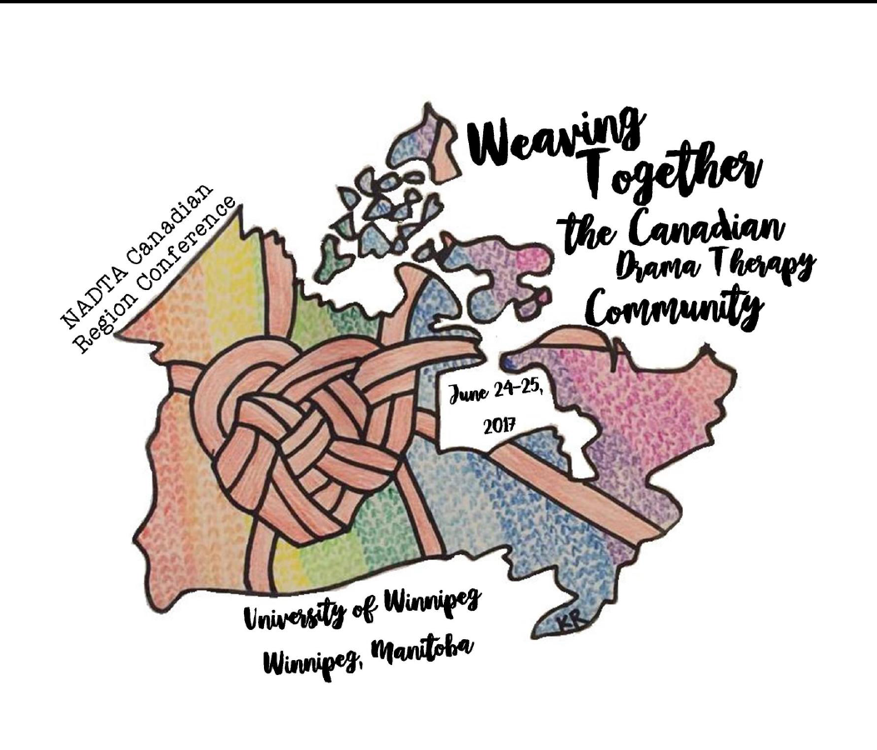

Canada: A Step by Step Guide To Hosting a Workshop (Regional Rep and/or Regional NADTA Groups)
Planning the event
1) Choose a topic that you think will draw a lot of interest. Hopefully something that will make money for your region.
2) Choose a workshop facilitator. Ask him/her to provide you with his/her fee.
3) Determine a price for the workshop:
a. Affordable (perhaps a lower price for students)
b. High enough to cover your costs and hopefully plus some…
4) Assess interest level for your topic, host city, price, workshop facilitator
5) Assess member availability for possible dates
1) & 2) can be assessed in the following ways:
- Survey
- Word of mouth
- Facebook conversations
- Cross Canada Zoom call conversations
- Parlour Talk conversations
(These are some ideas. You may have your own. You may choose to determine the topic and workshop facilitator based on the above communications with members.)
6) If you are not the Regional Rep, then contact your Regional Rep who will CC the NADTA President and President-elect for their thumbs up for moving forward (reginoal funding is accessible via the NADTA regional seed-money procedures). If you are the Canadian Regional Rep, you have steps (inlcuded in this manual) to follow at your discretion for creating various events.
Preparation For the event
7) Choose and book a venue, and finalize dates and times of event.
8) Create flyer for publicity.
9) Arrange how payments will be made – easiest is through the NADTA office at time of registration. Regional Reps must be the link to the office. All internet interactions go through the Regional Rep as point person for events. This prevents communication overload at the office and communication confusion.
10) Create Registration form together with Amber at the NADTA office. The Regional Rep protocol is listed in the manual. The office will help to add the conference information and all links to the main page. While this information will not be posted to the website until a future time, completing this task early on will provide time to work out any problems and provide the office ample time to complete all changes and actions necessary.
11) Apply for CEU’s with the CCPA (must be done a minimum of 6 weeks prior to the event).
12) Create workshop evaluation form (a template is provided in resource page of this manual)
13) Publicize confirmation of event with date that registration will open.
14) Open registration and publicize (posting flyer) that registration is now open by:
a. Email to Canadian member list
b. Canadian Region Facebook Group/Page
c. Concordia alumni Facebook Group
d. Other
15) Post frequent reminders
16) Once enough registrants are confirmed:
- book facilitator’s flight if applicable (keep receipt)
- Arrange for facilitator’s accommodation if applicable (keep receipt)
17) Pay for venue (keep receipt)
18) Arrange for materials needed for workshop (keep receipts)
19) Arrange for host billets for out of town registrants?
20) Have workshop facilitator write letter of welcome to registrants with any notes for preparation
21) Send facilitator’s letter to registrants
22) Request a list of all workshop attendees from the office
23) Make a list of all details needed to ensure all are comfortable and feel welcome for the workshop
The Event
24) Enjoy the Workshop! Take lots of pictures to later post on Instagram. Keep all receipts if you are covering facilitator’s meals and gift to be given at the end of the workshop.
25) Hand out evaluations at the end of the workshop.
26) Hand out CEU certificate provided by the CCPA if the workshop was approved.
After the event
27) Fill out NADTA reimbursement form, attach all receipts and submit to the NADTA office.
28) Celebrate and publicize success of your workshop!
- Post pictures on Instagram; 2) Create a collage of anecdotal responses to the workshop (taken from the evaluation form) and post to all places that you had publicized the event; 3) Send thank you cards to host billets (if applicable): 4) and Have a good, long sleep!

Canada: Regional Rep Overseeing Subcommittees
The Canadian Region Representative is an ad hoc member of all committees and subcommittees in the Canadian region. She/he/they may be present for some or all meetings, and may serve on the committee. If not present, Minutes of meetings need to be sent to the Canadian Rep. Conference Planning Committees are assembled by the Canadian Rep. and disbanded once the conference has ended.
Currently these committees include:
1. The Canadian Government Affairs Licensure Sub-committee
- Meets monthly.
- Chaired by a member of the sub-committee
- Overseen by the Canadian Rep. who sends the minutes to meetings to the overall NADTA Government Affairs Chair.
- Members currently include Provincial reps from Quebec, Ontario, Manitoba, Alberta, B.C.
The Canadian Rep over the past 4 years has served the Licensure sub-committee in the following ways over and above simply overseeing the committee:
a) Liaison between the committee and the NADTA board executive, lawyers, the Quebec chapter executive, other CAT associations, other FACTs, and Barb McCallum, the CEO of the CCPA.
b) Helping Provincial FACT reps with assembling and creating documents that represent the NADTA. These documents are then passed by the President, Presidentelect and the Government Affairs Chair of the NADTA.
c) Recruiting members to represent the NADTA on provincial FACTs or other government advocacy committee
d) Recruiting NADTA members to serve for their respective province on the Licensure sub-committee.
In the future, I recommend that the chair of the Canadian Licensure sub-committee be someone who is able to serve in all of the above functions, and who is not the Canadian Representative, as all of the above duties take time away from other regional rep duties.
2. The Parlour Talks Team Leads Committee
- Chaired by the Canadian Rep. and meets 4 times per year by Zoom.
- Members include Team Leads from all provinces/areas that host regular/semi-regular Parlour Talks Meetings
The goals for these meetings are:
1) To provide support to all of the provincial team leads and inspire them to continue reaching out to members in their smaller region.
2) To share information across the country and build on each other’s initiatives.

Canadian Membership Survey
Each Spring it is recommended that a survey be sent out to Canadian NADTA members, to ask for feedback regarding a variety of areas of interest and membership needs.
Survey Planet has a free survey option that works very well for this purpose, and results can be easily compiled and presented back to the membership.
Survey Example
Survey themes/ questions/content will vary from year to year. The 2019 survey questions were regarding professional development, community building and networking. The questions were as follows:
Q1: One idea has been for Armand Volkas to facilitate a 3 day workshop on how to guide clients through an Autobiographical Therapeutic Performance. Please indicate below how much this interests you
Not at all Interested / Mildly Interested / 50/50 / Extremely Interested
Q2: Would you be willing/able to pay $400US for a 3 day workshop with Armand Volkas?
Q3: If not, how much would you be able to pay?
Q4: If this workshop was to be held in Winnipeg, Manitoba, would you be able to attend if billeting was provided?
Q5: Please indicate which weekends you would be available to attend: Sept.20,21,22 or Oct.4,5,6
General professional development questions used for future Canadian Region planning
Q6: Where do you live in Canada?
Q7: Are you interested in having a local workshop facilitated by a local Drama Therapist?
Q8: Who would you like to have as a workshop facilitator and what (technique/method) would you like the workshop to be about?
Q9: Instead of a workshop, would you be more interested in attending a different sort of event for drama therapists in your area with food, beverages and music perhaps? Please indicate how likely it is that you would attend such an event.
Not so likely / somewhat likely / very likely / extremely likely
Q10: What type of event would interest you?
Party / Informal skills sharing / formal lecture or presentation / Workshops / Other
Q11: Would you pay $10 for a party in your area?
Q12: What would you recommend as a fee for a 1 Day workshop (that would match your ability to pay and the time and effort that the presenter will invest in presenting to you)?
Q13: What ideas do you have for professional development, networking, community building, skills sharing in your area?
Q14: If you shared an idea in the previous question, would you be willing to initiate your idea in your area? Yes/No or Explain
Q15: Would you be willing to brainstorm ideas with other drama therapists?

Survey Result Information:
The results of the survey were compiled and presented to the Canadian membership in three parts:
Part 1: Presenting the Armand Volkas Workshop in the Fall, 2019 – an outcome of the first part of the survey
Part 2: Smaller Regions within Canada Initiatives
Each province that had survey member representation received their own breakdown of ideas and interest levels for local workshops/events in their province. Based on the responses in that province, I also provided a recommendation for next steps to bring responses to action in that province.
Part 3: Cross Canada Overview of Survey Results--This provides an opportunity for members to compare and contrast responses between the provinces, and identify regional similarities and differences.

Applying for CEU’s in Canada
Canadian members have been able to submit for CEU’s with the CCPA for:
- Canadian Region Conference
- Approved Canadian Workshops
- Annual NADTA conferences
For the first time, we have received pre-approval from the Canadian Counselling and Psychotherapy Association for offering up to 40 continuing education credits for counselling related workshops and events from our conference this year. This is very exciting, as many, if not most of our Canadian NADTA members are also members of the CCPA, and need to submit a total of 36 CEU’s over the course of a three year period. This creates an added incentive for Canadians to attend our conferences, provides another benefit for our NADTA members, and simplifies the task of accumulating CEU’s (a task that can sometimes creep up on members at the last minute).
Steps to applying for CCPA CEU’s:
1) Find under “Forms” on the CCPA website the form for CEC Pre-Accreditation
2) Fill out the form
3) Submit form to email address provided together with additional material that they ask for
4) Make sure that all of this is done at least 6 weeks before the event

Payment & Reimbursement of Expenses Incurred in Canadian Dollars
Version 2, October 2017 Ratified by the NADTA Board: November 27, 2017
Adjustments: October 2019

Introduction
Since the NADTA is incorporated in the United States, bank accounts are in the U.S. and USD is the currency used by the organization. Members and Regional NADTA Groups residing in Canada may incur expenses in Canadian Dollars. These expenses will be paid and reimbursed in American Dollars as close to the equivalent of Canadian Dollars, spent and submitted, as possible. In addition, U.S. Banks do not mail checks to Canada.

Objective(s)
Ensure fair reimbursement of expenses incurred in Canadian Dollars.

Procedures
I. As with all expense reimbursements, members and Regional NADTA Groups will be required to complete a reimbursement form and provide copies of invoices or receipts in order to receive payment or reimbursement within 2 weeks of the cost being incurred.
II. In addition, the person who incurs the expense is asked to go to the Bank of Canada currency conversion website on the day the expense is incurred and enter the amount of Canadian dollars to receive the currency conversion to USD on the day requesting reimbursement. http://www.bankofcanada.ca/rates/exchange/daily-converter/
III. A printout or screenshot of the exchange for that day should be submitted along with the receipt and reimbursement form.
IV. Once the reimbursement request and supporting paperwork is received by the Office, the accounting staff will determine the conversion amount on the date the reimbursement is received in the NADTA home office for processing. For Canadian residents, reimbursement will be made based on the conversion rate on the date of reimbursement. For US residents who have spent Canadian dollars, reimbursements will be made based on the conversion rate on the date of purchase.
V. Since U.S. banks do not mail checks to Canada, checks will need to be sent by hand, which may take longer than mailing to the U.S. Due to daily fluctuation in the currency rate, Canadian members and Regional NADTA Groups are encouraged to deposit checks in a timely manner once received.

NORTH AMERICAN DRAMA THERAPY ASSOCIATION 1450 Western Avenue, Suite 101 Albany, NY
12203 T: (888) 416-7167 F: (518) 463-8656 nadta.org

NADTA Central Region Information and Guidelines

- Special Procedures or Considerations when Organizing the Central Regional Conference
- Example Proposals and Event Forms
- Zoom Meetings
- Social Media and Interaction
- Central Region Committee

Special Procedures or Considerations when Organizing the Central Regional Conference
General Regional Conference Guidelines and Recommended Timeline has been covered in Part 2 of this manual. This section is to provide procedures or consideration information that are special to Central Region.

- It will be very important to represent all locations/areas of the Central Region when determining the location of the regional conference. Attempt to host the conference in different geographical areas each year (also taking into consideration where the NADTA national conference will be held).
- If the NADTA national conference is being held in the Central Region, do not host a Central Region Conference during the spring beforehand and encourage Central Region members to become involved in volunteering with the national conference.

Example Proposals and Event Forms
The following examples are forms used by past Central Region Reps and may be altered to fit new ideas and needs of the current Representative.

Examples of Central Region Forms from 2017

- Conference Logo
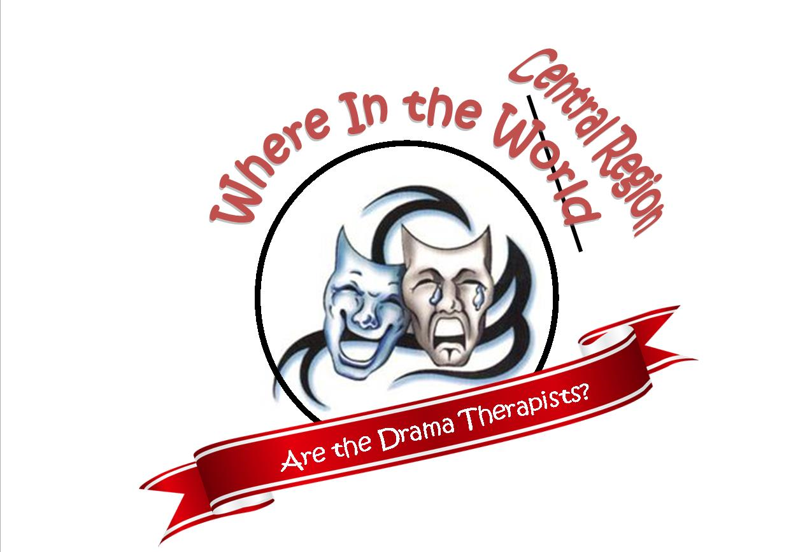

- Conference Proposal Letter

Dear Central Region Members,
I hope this message finds you all well and that you had a good holiday season and a good beginning to 2017!
Our Central Region Conference is scheduled for April 29 & 30, 2017 and will take place this year at Nichols Hall in MANHATTAN, KS at Kansas State University.
The theme this year is:
Finding Our Niche: Where in the Central Region Are the Drama Therapists.
At times, we in the Central Region can feel a little lost and lonely when it comes to finding work or opportunities for our work. While some may find a job as a drama therapist, others will incorporate drama therapy in their work or meld drama therapy into other helping fields.
This year at the Central Region Conference, we will invite our regional members to come together to share their techniques, examples, experiences, connections, and ideas of how they have found a place for themselves as a drama therapist within their work. We would like a variety of presentation-based and experiential-based workshops which include not only drama therapy but other professions that relate to drama therapy.
Rates for the conference will be the same as last year. The conference fee is $50.00 for students and $60.00 for professionals for the entire weekend. Those presenting will receive a $10.00 discount.
In addition, we will be offering four scholarships that will be utilized toward the conference fee. The scholarships will be provided to one student attendee, one non-student attendee, one student presenter, and one professional presenter. More information on these scholarships will be provided when the conference registration information opens.
No meals are included again this year; however, Kansas State University is near Aggieville, a small business section which includes many great restaurants such as Rock-A-Belly Deli, Keltic Star, and Bluestem Bistro, among many others. Additionally, we hope to help students connect with other students for housing shares.
*****Registration for the conference will be available at http://www.nadta.org starting early March 2017.*****

Proposals for the conference are due February 28, 2017.
Please copy and paste the template below and email your submission directly to the Central Region Representative at centralrep@nadta.org:
_________________________________________________________
Presenter(s) Name and Credentials:
Presenter(s) Email:
Presenter(s) Phone:
Professional Affiliations:
Current Student: Yes or No
Presenter Bio(s):
Name of Presentation:
Abstract (50 words MAX):
Three objectives of your talk (ex: participants will be able to identify three different types of eating disorders)
1.
2.
3.
Presentations can be either 1 or 1.5 hours, which do you prefer, if selected?
Please note the percent that is experiential, didactic or other:
Please note what presentation materials are needed (if applicable):

_________________________________________________________
Thank you and I hope to see a good turn out again this year in the Little Apple! We had a fantastic showing last year and would like to see us all connect again.
Alissa Duncan, M.A., R.D.T.

- Sample of Scholarship Application

Central Region Conference Scholarship Application

Name:
Email:
Phone:
Current Student: Yes or No
Presenter: Yes or No If yes, what are you presenting? ___________________________
Description of why you are applying for scholarship (50 words MAX):

Please submit form to Central Region Rep at centralrep@nadta.org by DATE.

- Example Wording for Attendance Letter - You will need to provide this information on offical NADTA Letterhead (request from main office)

Dear NAME OF ATTENDEE:

By attending this conference, participants earned 12 hours of continuing education.
Should you have questions, please contact the Central Region Representative at centralrep@nadta.org.

Sincerely,

NAME
Central Region Representative

Zoom Meetings
Zoom Meetings (Ideas for the Central Region)

Bi-annual (or quarterly) Zoom Meetings (or other teleconferencing tools) could be used to provide connection for regional members during the winter and summer months (depending on when the NADTA Conference and Central Region Conference is held).

The objective for these calls is:
- To inform new members of what the NADTA is and how it works
- To inform members of initiatives that exist across the region
- To empower members to create their own initiatives
- To unite AT and KSU students and address their questions
- To communicate clear delineations between the various NADTA reps that are at their service:
  - Central Rep. for community building, outreach (advocacy) and employment questions/issues across the region
  - Student Reps.at KSU and AT for all questions/issues relating to their education
- To answer all questions and address all concerns related to the NADTA

Ideas for Meetings:

Meetings could be a simple “meet and greet” meeting for members to discuss anything or meetings could have a specific topic that is of importance for the region. Topics might include:

  - Funding and How to Market Self in a “Non-DT Community”
  - Collaboration with Other CATS and Disciplines
  - Non-Clinical DT, Therapeutic Performance, Alternative Applications For DT
  - Compassion Fatigue/Self Care
  - Cultural Awareness and Conflict in the Central Region
  - Student Concerns While in School and Beyond

Social Media and Interaction
Social Media has become a big connection tool for the region. By using the three items listed below, the Central Region Rep will have the best chance at connecting with those on Social Media and those who rely on email notifications.

  - Member Spotlight - This is usually done via Facebook and Instagram (you could email it to those who do not use social media). The “Member Spotlight” highlights a person or group in the region and the work they are currently doing. It provides connection and insight into those in the region we may know or not know. An idea from a Central Region member was a “Spotlight and Tag” event to help keep the spotlight running.

  - Behind the Scenes - The Central Region Rep will submit a letter to the region 2-3 times per year (can do more) highlighting the work that they are doing and information/changes that may be of importance to the region.

  - Email Blasts - Used for general correspondence with the region, surveys, information about conferences/workshops, ect.

Central Region Committee
The Central Region Committee (now Regional NADTA Groups) - Because of the vast area that the Central Region has, it may be a good idea to have a committee of people who can act as a liaison for that geographic area. These individuals may have insight into happenings in the area or could be a point of contact for license/practicing issues or general information for those moving into that area. It is recommended to encourage these individuals to create NADTA Regional Groups to promote connection and increase understanding of that particular area of the region.

NADTA Eastern Region Information and Guidelines

- Special Procedures or Considerations when Organizing the Eastern Regional Conference
- Social Media Presence

Special Procedures or Considerations when Organizing the Eastern Regional Conference

General Regional Conference Guidelines and Recommended Timeline has been covered in Part 2 of this manual. This section is to provide procedures or consideration information that are special to Eastern Region.

Below you find an example of the 2013 Eastern Region Conference and applicable information:

2013 Eastern Region Conference

Saturday, April 6th, NYC

8:00 am to 8:00 pm
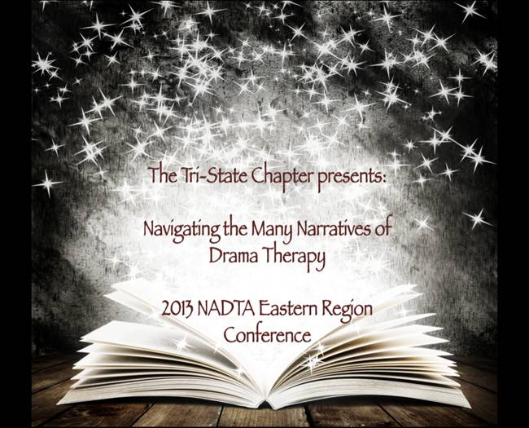
Navigating the Many Narratives of Drama Therapy
Narratives shape people, experiences, practices, and history. To navigate the direction of our medium, we as drama therapists have had to reflect upon, maneuver and determine our own narrative over the last thirty plus years.
In his book Consciousness Reconsidered (1993), Owen Flanagan states, “Evidence strongly suggests that humans in all cultures come to cast their own identity in some sort of narrative form. We are inveterate storytellers" (p. 198). The idea of storytelling and narrative as a function of the construction of one’s identity is an integral part of the theoretical and clinical work of drama therapists. As we well know, narratives are produced and navigated not only by individuals but by groups, communities, societies, and cultures which maintain awareness of the connections between past, present, and future. As a field, drama therapy has its own identity made up of a vast variety of narratives and stories that provide our history, shape our current self-concept, and fashion the future of our profession. The narrative of drama therapy combines the actions and events that affect all of the human lives involved. To continue to live our collective story we must know where it is we have come from and honor the narratives that have been told before us, as well as nurture and continue the narratives that will change our professional path. How are we staying current and updating our narratives to remain relevant and relative to the lives of our clients and the greater mental health community?
As drama therapists our art, techniques, and process form the narrative of our daily professional approach. Our experience of the individual and group work we do with clients as well as the stories that we share with colleagues, and our personal reactions to this challenging work help to shape the everyday story of drama therapy. These narratives form the foundation and springboard for where we hope to go—personally, clinically, and professionally. As the next generation of drama therapy emerges, we are exploring the stories and narratives that will sustain our practice and direct the future of our field. A narrative is not the story itself but rather the telling of the story – How has drama therapy been retold over the years and how is the description and work changing to tell a new one? This conference, and its intention, is to begin a dialogue and a new narrative. Like turning pages of a novel, each passing year is the continuation of drama therapy’s story. This conference wants to pay homage to all of the stories that have brought us to our current point and will explore the personal, clinical, educational, and future-looking chapters of our narrative as a field.
At this conference you will have the opportunity to choose your own path. Like the chapters in a book, each will build on the other to navigate and guide you in a direction that most fits your curiosity and creativity at this moment in your career. Each chapter will offer insights into our profession’s narrative while giving you a chance to consider where you, the protagonist, envision your role in the narrative.
- Chapter One: Personal Story These workshops explore stories centered around the personal drama therapy projects and practices of professionals in the field, as well as the effect that this work has had on practitioners. Who are we as drama therapists? How has our work affected our personal lives? How have the struggles and successes inherent in the work shaped the narrative?
- Chapter Two: Clinical Story This track will examine the clinical applications and environments of our work. Populations, settings, methodology, and the stories of advanced practices will be discussed within the framework of the arc of our field. How are the settings in which we work changing or embracing our narrative? What are the innovative practices that are bridging the gap between drama therapy and alternative therapeutic methods and modalities?
- Chapter Three: Educational Story These workshops will examine the theoretical underpinnings from which drama therapy has sprung, and will offer new and innovative ways in which to continue broadening your knowledge base. How does one stay inspired, current, and growing in one’s practice? How can we as clinicians continue to educate ourselves and stay connected to our field, while expanding our scope of practice?
- Chapter Four: Future Story This cluster of workshops envisions and experiments with the future trajectory of our profession and field. Where do you believe we are heading as a community? What are we capable of bringing to the larger narrative of the mental health and creative arts communities? How are we advocating for the growth of our field?
It is time to let drama therapy’s narrative navigate the future.
Please join us for the 2013 NADTA Eastern Region Conference, “Navigating the Many Narratives of Drama Therapy,” hosted by the Tri-State Chapter. We hope that you will share your story with us, navigate the unknown, and lend your experience to the development of the narrative.
Saturday, April 6th, 2013
Venue: Roy Arias Theater Center – 777 8th Avenue – Between 47th & 48th Street – Second Floor - New York, NY 10036
Registration begins at 8:00AM – Opening ceremony at 8:30AM.
Regularly scheduled workshops begin and end promptly at 9:00AM-5:10PM.
Closing Ceremony – 5:10-5:40PM.

Special Keynote Presentations
(For participants who attended the entire conference - additional $15.00 includes one workshop and food/beverage)
Attendance for the single workshop including food/beverage – $25

6:30-8:00PM
Venue: New York University – 35 West 4th Street, Third Floor -New York, NY 10012

“Past, Present, and Future: Uniting the Narratives of Generations”
OR
“Bridging into LCAT Private Practice: Vision and Challenges”

If you have any questions feel free to contact the co-chairs of this conference at: nadtatristatechapter@gmail.com or tristatechapter@nadta.org
“A tale shall accomplish something and arrive somewhere.” ~ Mark Twain

We hope to navigate alongside of you,
Jeremy Segall, MA, RDT, LCAT, CONFERENCE CO-CHAIR / TRI-STATE CHAPTER PRESIDENT
Elizabeth Edwards, MA, LCAT (PERMIT), CONFERENCE CO-CHAIR / TRI-STATE CHAPTER VICE PRESIDENT
On behalf of the Tri-State Chapter board and Conference Program Committee

Sample Conference Layout and Program Information:

Saturday, April 6, 2013

Roy Arias Theatre Center
and
New York University

“A tale shall accomplish something and arrive somewhere.” ~ Mark Twain

Morning Schedule

8:00 - 8:30 Registration/Breakfast
8:30 - 9:00 Opening Ceremony
9:00 – 12:10 Morning Workshops

Long Workshop A (9:00 – 12:10) (3 hours)
A1: Special Affects: 21st Century Narratives --FUTURE

Short Workshops B (9:00 – 10:00) (1 hours)
B2: The Mural Project: Unearthing Narratives in Dementia Care --PERSONAL
B3: Narrative in an Alternate Context: The Use of Actors to Train Doctors --EDUCATIONAL
B4: No One Ever Listens to Me: Drama Therapy and the Value of Counternarratives --CLINICAL

Short Workshops C (10:10 – 12:10) (2 hours)
C2: School Interrupted: Trauma and College Bases Treatment Settings --EDUCATIONAL
C3: Untold: Struggles from the Fringes of Creative Arts Therapies --PERSONAL
C4: Challenges in the Confluence of Narratives: The Client and the Therapist --CLINICAL

12:10 – 1:00 Lunch

Afternoon Schedule

1:00 – 3:00 Afternoon Workshops D
D1: Sensory Modulation Practices for the Creative Arts Therapists Working with Trauma --CLINICAL
D2: Stepping into Story: The Use of Drama Therapy in the PROS Recovery Model --EDUCATIONAL
D3: Finding and Navigating the Balance between Business and Creativity --FUTURE
D4: Singing the Role, Playing the Part --PERSONAL

3:10 – 5:10 Afternoon Workshops E
E1: Esmin: Four Years Later --CLINICAL
E2: But I Came To Heal: When Institutions Wound Therapists --PERSONAL
E3: Lunatic, Warden, Savior, Spy: Surviving Negative Projections within our institutions --CLINICAL
E4: Discovering the Full Spectrum of Self as Drama Therapist --PERSONAL

3:10 – 5:10 Closing Ceremony

Evening Schedule*

6:30 – 8:00 Keynote Presentations
K1: Bridging into L-CAT Private Practice: Vision and Challenges FUTURE
K2: Past, Present, and Future: Beyond Narratives of Generation FUTURE

* Please note the evening programming will be presented at New York University. The address and directions have been provided on a separate insert in the conference program packet.

Workshop Abstracts

Workshop A1: Special Affects: 21st Century Narratives
Presenters: Shira Hon, Jon Ehinger, Joe Kavitski
This presentation will focus on combining clinical aspects of the therapeutic process with computer-based approaches to creative arts therapy.

Workshop B2: The Mural Project: Unearthing Narratives in Dementia Care
Presenters: Kate Schober, RDT, LCAT (Permit) and Joe Kavitski
This presentation focuses on the utilization of multiple creative art therapies as a way to assist those with dementia in recalling stories from their lives. In the documentary, All Are Welcome, a collaborative mural project completed at Bishop Hucles Nursing Home, viewers will witness residents as they work together to create a holding space for their personal and collective narratives.

Workshop B3: Narrative in an Alternate Context: The Use of Actors to Train Doctors
Presenters: Terry Sommer, BFA and Adam Reynolds, MFA, LMSW, RDT, CASAC
This session will offer a look at the now ubiquitous use of actors as Standardized Patients (SPs) in American medical schools. SPs are used to train a wide range of competencies, among them, how to better hear and understand the patient’s story, thus enabling the best possible care for the patient.

Workshop B4: No One Ever Listens to Me: Drama Therapy and the Value of Counternarratives
Presenters: Daniela Bustamante, MA, LCAT (Permit)
As the old adage goes, "there are two [or more] sides to every story." For every narrative we hear and uphold, there is another which remains unheard, and unwitnessed.

Workshop C2: School Interrupted: Trauma and College Bases Treatment Settings
Presenters: Navah Steiner, MA, RDT, LCAT
What happens when traumatic memories or a current traumatic event emerges in treatment at a short term, college based counseling center? In this workshop, a drama therapist, working with visual art students, will explore the presence of trauma and treatment implications for this client population. This presentation will include case presentations, theoretical perspectives and experiential reflections.

Workshop C3: Untold: Struggles from the Fringes of Creative Arts Therapies
Presenters: Pamela Edgar, RDT, LCAT, CDP and Elisabeth Davis, LCAT, RDT
Within the CAT community, there are stories of disconnection, struggle and disillusion. In this experiential workshop we will explore these personal stories through ritual and enactment. Participants will support truth-telling and transformation in a safe and confidential environment. Come find your voice, claim your place and experience your creative power!

Workshop C4: Challenges in the Confluence of Narratives: The Client and the Therapist
Presenters: Jacob Gershoni, LCSW, CGP, TEP
What we learn from our clients is invaluable for our professional and personal growth. At times, however, clients’ issues conflict with our own struggles from the past and present. Sociometry and psychodrama will be utilized to address counter transference issues in this workshop, aimed at a higher level of creativity.

Workshop D1: Sensory Modulation Practices for the Creative Arts Therapists Working with Trauma
Presenters: Jeremy Segall, MA, RDT, LCAT, Carlos RodriguezPerez, MA, RDT/BCT, LCAT, Kelley Linhardt, MA, ATR-BC, LCAT, Suzanne White, MA, OTR/L, Jenna Wood, MA, MT-BC, LCAT
Sensory Modulation is a clinical practice developed by Occupational Therapists that works to meet sensory stimuli to increase well-being. Sensory experiences and the metaphors related to them are often evoked in CAT. Incorporating Sensory Modulation techniques into CAT can improve clients' ability to remain emotionally-present during moments of dysregulation, helping us to better treat trauma.

Workshop D2: Stepping into Story: The Use of Drama Therapy in the PROS Recovery Model
Presenters: Dana Trottier, MA, LCAT (Permit), Britton Williams, MA, LCAT (Permit), Ashley Kleinman, MA, LCAT (Permit).
Hosted by Sara McMullian, MA, RDT-BCT, LCAT
Drama therapy as an action based method offers rich opportunities within the Personalized Recovery Oriented Services (PROS) model to develop prescriptive curriculum based groups where clients are able to "try on" and inhabit roles. This presentation will illustrate and offer narrative for specific prescribed groups to demonstrate the efficacy of this work.

Workshop D3: Finding and Navigating the Balance between Business and Creativity
Presenters: Brooke Campbell, MA, RDT-BCT, LCAT, Andrew Rizkalla, MPA, CFE, and Samantha Peller, MA, RDT
Starting our own businesses, practices and other types of creative ventures can leverage our skills and creativity to steer our careers in a more authentic, empowered, and forward direction. Artists and healers often struggle when it comes to the world of business, finance and “left-brained” concepts. In this focused workshop attendees will gain business tools to support their professional growth.

Workshop D4: Singing the Role, Playing the Part
Presenters: Rebecca Dolan and Jen Waldman
This workshop will invite participants into the experience of Musical Theatre Therapy, a technique that combines drama & music therapies using a musical theatre training model. After a brief didactic explanation, participants will work individually & as a group using prepared songs to explore personal catharsis & role repertoire expansion.

Workshop E1: Esmin: Four Years Later
Presenters: Kate Hurd, MA, RDT/BCT, LCAT, Prentiss Benjamin, MA (Candidate), and Leticia Kuyumciyan, MA, RDT, LCAT
Additional Cast Members: Charisse Brown, Jarred Sharar, and Russ Roten
A woman named Esmin died in the psychiatric emergency room of a city hospital. Her story was evidence of brokenness, indifference and disconnection. Organizations, like individuals, can be organized around a traumatic event. How has Esmin affected both the organization and the individuals that work there? Interviews with staff will be the basis for a scripted dramatic enactment.

Workshop E2: But I Came To Heal: When Institutions Wound Therapists
Presenters: Andrew Gaines, LCAT, RDT-BCT
This workshop offers a forum in which to safely explore, express and work through traumas that have occurred in and around the workplace. Drama therapy techniques will be applied to a trauma-informed model of supervision as we honor professional struggles and identify tools for self-care through play, discussion, and psychoeducation.

Workshop E3: Lunatic, Warden, Savior, Spy: Surviving Negative Projections within our institutions
Presenters: Adam Reynolds, MFA, LMSW, RDT, CASAC and Elisabeth Davis, LCAT, RDT
“You’re as crazy as they are!” “I’ll do anything to get out of here.” “You’re the only one who understands me.” “Are you going to tell them what I did?” Some of the most powerful roles we play are not chosen, but projected on us. We explore four of them.

Workshop E4: Discovering the Full Spectrum of Self as Drama Therapist
Presenters: Emily Ward, RDT, LCAT and Kristen Brookes, RDT, LCAT
This experiential workshop is designed to nourish and strengthen us as drama therapists. We will explore our emotional range and role repertoire within our professional identity and emerge ready to express a fuller spectrum of who we are through our work.

Workshop K1: Bridging into LCAT Private Practice: Vision and Challenges
Presenters:

Workshop K2: Past, Present, and Future: Beyond Narratives of Generation
Presenters:

Presenter Biographies:

Prentiss Benjamin, MA (Candidate) is a 2nd year drama therapy student at NYU. She graduated from Northwestern University and has appeared Off-Broadway and in regional theaters across the country. Prentiss is currently interning at Mount Sinai Hospital.
Kristen Brookes, RDT, LCAT graduated from CIIS. She has worked as a Site Director and Drama Therapist with ENACT. She now works as a Drama Therapist with CANY and has just begun her private practice in Brooklyn.
Brooke Campbell, MA, RDT-BCT, LCAT is the Founder of Creative Kinections LLC partnering with hospitals, recreation centers, and a leading domestic violence agency. She is a Board Certified Trainer and has lectured at universities and national conferences. She has supervised professionals and graduate students. As a professional actor, she is a member of SAG-AFTRA and AEA. She is a published writer and has contributed for various well-known parenting and relationship websites. (www.CreativeKinections.com)
Elisabeth Davis, LCAT, RDT is a drama therapist at Mount Sinai Hospital in inpatient psychiaty. She is an adjunct professor at The New School University. She is also enrolled in the MSTOM program at Pacific College of Oriental Medicine for acupuncture and nutrition.
Rebecca Dolan With a background in musical theatre performance, received MA in Drama Therapy (NYU). Currently working as drama therapist on Child/Adolescent Inpatient Service at Kings County Hospital Center. Serves as Program Committee Chair for Tri-State Chapter.
Pamela Edgar, RDT, LCAT, CDP is the Northeast Region Clinical Coordinator for Compassion & Choices. Pam is committed to her own journey of discovery and healing, and deeply honored to join others on their journeys.
Andrew Gaines, LCAT, RDT-BCT has worked in private practice and at several hospitals in NYC over the last 10 years. He is a PhD Candidate and frequent Guest Lecturer at NYU, and former NADTA Tri-State Chapter President.
Jacob Gershoni, LCSW, CGP, TEP is in private practice and co-director of the Psychodrama Training Institute in New York City and the editor of “Psychodrama in the 21st Century: Clinical and Educational Applications” (Springer, 2003).
Kate Hurd, MA, RDT/BCT, LCAT is an LCAT Supervisor at Kings County Hospital, Brooklyn, NY, is in private practice at Off Center in Chelsea, and is a former President of NADTA.
Ashley Kleinman, MA, LCAT (Permit) is a graduate of New York University’s Drama Therapy program. Ashley works at HeartShare Human Services of New York’s Creative Solutions for Families where she provides home-based drama therapy within intensive preventive services.
Joe Kavitski is an award-winning filmmaker, artist, and writer studying Art Therapy at New York University. He is an Advanced Level Reiki practitioner and an Art Therapy intern at Woodhull Medical Center.
Leticia Kuyumciyan, MA, RDT, LCAT holds a BA in Psychology and Drama from the University of Virginia, and a MA in Drama Therapy from NYU. She currently works as a creative arts therapist at Kings County Hospital.
Kelley Linhardt, MA ATR-BC, LCAT, received her Master's in Art Therapy from NYU, a certificate form the International Trauma Studies Program and is currently training at the Ackerman Institute. Her interest is in creating resilient communities through creativity.
Sara McMullian, RDT-BCT, LCAT is currently a Coordinator for FEGS Bronx PROS Possibilities. She is an adjunct professor at NYU's Master's Program in Drama Therapy, and serves on the NYS Board for Mental Health Practitioners.
Samantha Peller, MA, RDT is a National Clinical Trainer for Phoenix House where she trains staff treating clients with drug and alcohol issues. She previously worked as a drama therapist with clients suffering mental illness, autistic children and medically ill children. She has presented at many conferences and has started a company to teach business skills to creative professionals.
Adam Reynolds, MFA, LMSW, RDT, CASAC is the Clinical Manager of Psychiatric Rehabilitation at Mt. Sinai Hospital and the Associate Training Director for the Institute for DvT in NYC. His relationships with the Institutions in his life are complicated.
Andrew Rizkalla, MPA, CFE has twelve years experience working in the private and public financial sectors. He received his Masters in Public Administration (executive program) at NYU Wagner's Graduate School of Public Service. He holds numerous certifications and received his Bachelor of Science in Accounting. He is a certified fraud examiner and business manager for Creative Kinections, LLC.
Carlos Rodriguez-Perez, MA, RDT/BCT, LCAT is a graduate from the NYU Drama Therapy Program, and a past President of the NADTA. Currently he is the Associate Director of the Therapeutic Rehabilitation Department at Kings County Hospital Center in Brooklyn, NY.
Kate Schober, RDT, LCAT (Permit) is a graduate of the NYU Drama Therapy program. She has worked at Bishop Henry B. Hucles Episcopal Nursing Home with residents in dementia care, short-term rehabilitation, and end-of-life care. She currently works at the Hebrew Home at Riverdale.
Jeremy Segal, MA, RDT, LCAT works at Kings County Hospital with inpatient youth. A life/career coach practicing privately for seven years, he is Tri-State Chapter President, co-chair of this conference, and a member of the NADTA Task Force.
Terry Sommer, BFA [Former actor/improviser (25 years); Director, The Morchand Center (Icahn School of Medicine at Mount Sinai, 7 yrs); Graduate of Center for Group Studies, (a NYC psychoanalytic training institute); Drama therapy training: Creative Alternatives CANY.]
Dana Trottier, MA, LCAT (Permit) is a Creative Arts Therapist Level I at Kings County Hospital Center working with adults on a psychiatric inpatient unit. Dana is a graduate of the NYU Drama Therapy program.
Jen Waldman Owner of Jen Waldman Studio & Co-Artistic Director of Breaking Bread Theatre. As an actor, she has appeared on Broadway & on stages in 28 states. Theatre Chair for the National Young Arts Foundation.
Suzanne White, MA, OTR/L is a faculty member of the Occupational Therapy program at SUNY DOwnstate Medical School of Medicine. She has been collaborating with the hospital and Health Corporation on the integration of Sensory Modulation practices.
Emily Ward, RDT, LCAT is the Director of Training and Research and Drama Therapist at ENACT, works with students, staff and parents. Emilie also Co-facilitates "Theater Lab: Real People Doing Real Theatre,” with Cecilia Dintino Psy.D, RDT.
Britton Williams, MA, LCAT (Permit) is a recent graduate of the NYU Drama Therapy program. She currently works full-time at Creative Alternatives of New York.
Jenna Wood, MA, MT-BC, LCAT is a music therapist at Kings County Hospital Center. She completed her Master's degree at NYU in Music Therapy and holds an undergraduate degree in piano performance from UNC at Chapel Hill.

The NADTA Eastern Region Conference Committee Members:
Jeremy Segall, MA, RDT, LCAT
Conference Co-Chair
Elizabeth Edwards, MA LCAT (Permit)
Conference Co-Chair
Jason Conover
Rebecca Dolan
Courtney Dowdell
Lisa Gail
Morgan Geisert
Ashley Kile
Leticia Kuyumciyan, MA, RDT, LCAT
Carla Mercun
Caroline Moore
Maggie Robbins
Kate Schober, RDT, LCAT (Permit)
Britton Williams, MA, LCAT (Permit)

Special Thanks to
Studios353 Rehearsal Studios and Halls
for their donation to this conference.
www.studios353.com

Social Media Presence
NADTA Tri-State Social Media Guidelines
Style Guide Purpose:
The purpose of this document is to outline style guidelines for NADTA Tri-State’s central social media accounts. This document will be updated as needed, please see the upper right for the initials of the update and the date.
Active Accounts:
- Instagram/nadtatristatechapter
- Instagram/NADTAEasternRegion
Branding:
- Intention: Community, Connection and Conversation
- Tone of messaging: Bright, engaging uplifting, welcoming
- Voice: Fun, informative, empowering
- Primary Brand Colors: Black, White, Red
o Secondary/Tertiary Colors: Muted peach, Turquoise
Fonts and Typography:
- The use of a sans serif font in bold for titles and headlines
- We specifically request: Couture
- The use of a sans serif font in regular or thin for paragraphs/text
- We specifically request: Quicksand

Ownership of Posts:
- All messages on all central media platforms are posted in the character voice described above
- We DO NOT attach names or initials to posts
Positivity and Transparency:
- We present our messages with a positive attitude, but are honest and transparent in the information we share
General Style Guidelines:
- Other Accounts/Sources
o We will always do our best to reference another account (when available or appropriate) in any message that we share
o When possible, please tag the account in the photo
Dates and Times:
- For times, use am and pm, all lowercase and no periods, with a space between the number and the letters (8 pm)
- Use a dash in between the times (2 pm - 4 pm)
- Please write out full dates and days of the week, unless space is required. (Monday, January 14, 2019 8 pm - 10 pm OR 1/14/19 8pm - 10 pm)
Notes on Punctuation:
- The use of proper grammar based upon the Oxford English standard, and using APA guidelines is imperative
- The use of emojis within the caption or image is not requested
- When posted the use of the “Royal We” throughout is requested
- The total number of exclamation points should not exceed two throughout the post
- Use an ellipses to show when something has been omitted
- All links will be shortened to a bit.ly link
- Avoid using more than three mentions or tags to another account
Instagram Guidelines:
- The post should contain no more than 4 hashtags
o Approved hashtags: #nadta, #nadtatristate, #dramatherapy, #(whatever the season is), a # that is trending for that day (that is also relevant to the post)
- The Instagram, because it is image based, should contain no caption below except for the above hashtags
o If there is information to be had in the caption portion of the Instagram no more than 180 words
Image Guidelines for Instagram:
- All images will use the same two filters, either Inkwell or Lo-Fi at 55% depending on the time
- Any photos used for promotional purposes must be a candid shot, using the rule of this with the proper exposure and light settings
o The artistic lens/point of view is the capture of a joyful candid moment in community
§ The tristate membership chairs reserve the right to reject any photos
- Because the Instagram is our current main way to communicate our events the guidelines listed will apply to any promotional flyers and poster(s) created for any events
- Additional guidelines
o The promotional flyers cannot be an image based background unless approved by the membership chair(s)
o The promotional flyers must call within the branding standards mentioned above
o All text on the image must be clear and visible and not lost in any background material/ image / clip art
o The name of the event must be 35% larger than the rest of the text on the page
o The following must be included in every promotional flyers: NADTA Tri State presents
o The email (nadtatristatechapter@gmail.com) must be included on then image
Cadence:
- Instagram
o Three posts a week between Monday and Friday only
o Between the hours of 7am-9am &/or after 5pm Two weeks from event: a stop motion reminder
o 1st of the month from the event: save the date (canvas image)
o 5 days from the event: creation of an event countdown
o Day of event: a video from one of the board members reminding them about the event, etc.

NADTA Western Region Information and Guidelines

- Special Procedures or Considerations when Organizing the Western Regional Conference
  - Examples and Flyers of Western Regional Conferences
- Presenter Series
  - Examples and Flyers of SoCal Presenter Series
- Intro to Drama Therapy Public Workshops
  - Example and Flyer of Drama Therapy Public Workshops
- The Nuts and Bolts of Creating Workshops: SoCal Dialogue
- Template: Organizing the Planned Three-hour Workshop Day
- Aiding Current Western NADTA Regional Groups
  - SoCal
  - Pacific Northwest

Special Procedures or Considerations when Organizing the Western Regional Conference
- Choose workshop facilitators. The SoCal Region and Pacific Northwest have not had to offer a fee to presenters. Only recently, SoCal offered an honorarium for a keynote and a Playback troupe. Usually, only a transportation stipend for local presenters is offered as well as perhaps a gift card and thank you notes. We find that very talented people who have expertise are willing to share their knowledge with both these regional groups. One group has been functioning as the only chapter in California and the first that has ever existed in the region. Perhaps this is one reason there has been an interest among different social services professionals in being involved with them.
- This conference can be an undertaking and requires a large enough space for breakout sessions, which might entail two to three very large rooms to schedule groups throughout the day-long conference. Affordable space is the one challenge and ingenuity in the use of available affordable space is the other.
- Western Region Conferences or symposiums have featured a keynote guest and several workshops in order to generate larger attendee turnout and information that goes out into the larger Los Angeles community and beyond. The conferences have attracted drama therapists and other CATS from northern california as well.
  - The keynote for one conference was a well-known UCLArts and Healing Program director who founded a music therapy/drumming program and the other keynote featured a well-known drama therapist and his Playback company from San Francisco.
- The conference/symposiums offers affordable lunch and free breakfast fare as well as the traditional raffle of books by featured authors or drama therapy toys.
- The conference/symposiums offer opportunity for volunteer students who do not have a masters to attend for what they can afford (minimum 20.00). They attend the day’s event one hour earlier than it begins and one hour after the event ends and may be given jobs such as emailing or other errands (buying food or coffee)before the event. This is at the discretion of the event producer/Chair or regional rep. Student volunteers who are given and shown specific jobs for a conference can basically help produce an entire event.
- Student rate for those attending a drama therapy school or college for counseling has been $ 65.00. Those individuals may get a discount for volunteering if the conference chair needs help. This is at the discretion of the chair(s). I suggest not more than 10.00 to be fair.
- Professionals pay $ 95.00 for large events such as conferences, which have been inclusive of the cost of the CE’s they earn. They may get a discount if they volunteer but this is at the discretion of the producing body, the chair or regional rep chairing. To be fair to other professional and student attendees, we consider a maximum of 10.00 as a discount because they are earning CEs which are are worthwhile and worth the money.
- If you have student volunteers or non professionals volunteering, you can get all the help you need and it would be fair to keep the professional discounts at a minimum.
- Liability insurance (see info on one-day event insurance in reference section of this manual) is crucial when you have large numbers of people attending. The SoCal regional conferences generated 80-100 people in attendance. Cost of liability was approximately $ 75.00.
- Create your flyer with all the information needed on it for your event from a visual arts group group member or use Fiverr.com and get a flyer made for cheap ($10.00-15.00). Registration forms can be finalized via the NADTA office (Amber at the NADTA office) by creating a link to the flyer. Completing this task early is advisable incase there are any glitches. Note the time difference between the east coast where the office is and west coast if you have deadlines to meet or an emergency. Your flyer needs to be public and linked to the NADTA website via the office at least six weeks before your event in order to give people ample time to learn about your event and reserve their spot.
- Publicize your flyer. Contact local city publications, local list serves for city events, universities, colleagues. List on your group facebook page. Consider starting a MEET-UP group. Consider theatre arts and psychology departments as well as Occupational Therapists, Certified child life specialists and other regional CAT groups and social worker groups, clinics or schools. Be creative in your pursuit. Find and email regional NADTA members to attend through our NADTA office or our new BCT online listing.
- Additional Income. Ask a clinic or colleague with a business such as a drama therapy school or another local business if they want to buy ad space in the program or buy an advertisement table or contribute pens or note pads with their logo for the attendee conference bags? This will bring you additional income for your event or save you money with free items to include in a conference bag.
- Cost/fee of printed ads and advertising tables for those attendees wanting business publicity have in the past each been $ 25.00 for regional events. Ads are business card sized to be printed in the required program. This is up to the discretion of the event chairs.
- Determine how many Tables (8 or 10 ft long) you will need to rent to display peoples ads, for breakfast items, for sign up table at the door, for NADTA brochures and conference info, etc . Can the tables be part of the rental cost of a space? Table cloths will need to be purchased or volunteered. There are cheap cloth, paper or plastic ones.
- Arrange how payments will be made by attendees .The easiest way is through our NADTA Memberclicks registration that will be linked on a flyer that you can promote as an electronic flyer. Payment and registration occurs asap and you then can depend on a head count for your event. Simply call the office periodically to check on your attendance numbers and gear your advertising push around that.
- A few weeks before your event, make certain if you don’t already have it, that the NADTA square account and the square reader have been sent to you. The office will help you once you call and ask them for it. You can then take credit card payment at the door on the day of.
- The rules for CE’s must be understood and reviewed in the NBCC book. Know what and how to offer CE’s . You can contact the Education chair and CE committee for more info. Some basic info is included in the resource section of this manual. The NBCC requires that each session in your event have a workshop evaluation form that must be filled out by the attending participants. Therefore, you must provide these by printing enough of them out (consider attendance headcount) for the event for CE credits that are being offered and for NADTA/RDT continuing education needs (See guides and sample of evaluation form in resource section of this manual).
  - There must be a sign in and sign out sheet for licensed therapists. It is imperative that the sign in sheet be available and I recommend people assigned from your group announce sign in and sign out rules for each workshop session or event or else the licensed attendee can not get their CE credit per NBCC protocol.
  - If you have a large turnout and assume you will, I also recommend cross referencing names and therapists’ license numbers at your event from the sign in at the door to the sign in and sign out sheets from the sessions. Have the licensed practitioners sign in at the door with their license information at the sign in table. You will have your registrants’ names and some info from the NADTA office. The office will have many of the registrants names from their electronic payment from the flyer but not everyone’s due to late registration, choice to pay at the door. When registrants sign in at the door and sign in AND sign out of the session they attended, the person completing CE certificates (after the event is over) will have another attendance reference sheet with the licenses and names listed that all will hopefully be legible.
  - CE’s get sent to attendees via email. Both the office will have a legible contact for the attendee and the sign in sheets will provide for that as well. (see CE certificate in resource section of this manual)
- Purchase conference attendee bags from Amazon, etc to place pens/pads and conference schedule, evaluation sheets, flyers for business advertising, etc.
- Do you need to design and purchase a professional looking sign with the NADTA logo outside your building to direct attendees to the event? Do you need a table banner or runner purchase on-line--(see resource page or make a cheap but professional cardboard stand at Kinkos) to designate the conference flyer, your regional logo or the event title in the entrance area where you are signing in attendees? Can you borrow the NADTA table runner from the office for this event and get it in the mail, then return it?
- Other Rentals? Can you get free projectors and screens for powerpoint presentations? Do you have to rent them? Should your group invest in purchasing a projector for the long-run? Do you have a table for the projector? Do you need a podium for the keynote?
- Do you have internet access in your space if needed for presenters?
- Design your program in accordance to NBCC rules (see guide info in resource section of manual) and create conference attendees bags. Place presenter images, bios and session descriptions and objectives per NBCC protocol. Designate a team to do this.
- Design your Evaluation Sheets to include the title of the conference and the different session names.
- Decide if you will purchase affordable bags to include attendee conference bags with items such as raffle ticket, conference schedule, programs and eval sheets, flyers from supportive advertisers and small notepad or NADTA logo pen.
- Get a minimal amount of cash for change in case some attendees want to pay with cash at the door.
- Info on attendance helps at the sign in at the door and will help determine who already paid and offer you the attendance headcount so you can arrange rooms (the day before or same day early morning via volunteers) for seating and arrange amounts of attendee conference packets with ad flyers, gift logo pens or pads and conference/symposium schedule and program/ and or lunch items.

Examples and Flyers of Western Regional Conferences

Regional Conference Saturday, February 27, 2016
"Out of the Box: the Practical and Integrative Uses of Expressive Arts and Drama Therapy"

Keynote speaker - Ping Ho
Greater Los Angeles Agency on Deafness (GLAAD), Los Angeles, CA

With 15 Creative Art Therapy Presenters

On flyer (note Memberclicks link & required NBCC logo and NADTA logo)

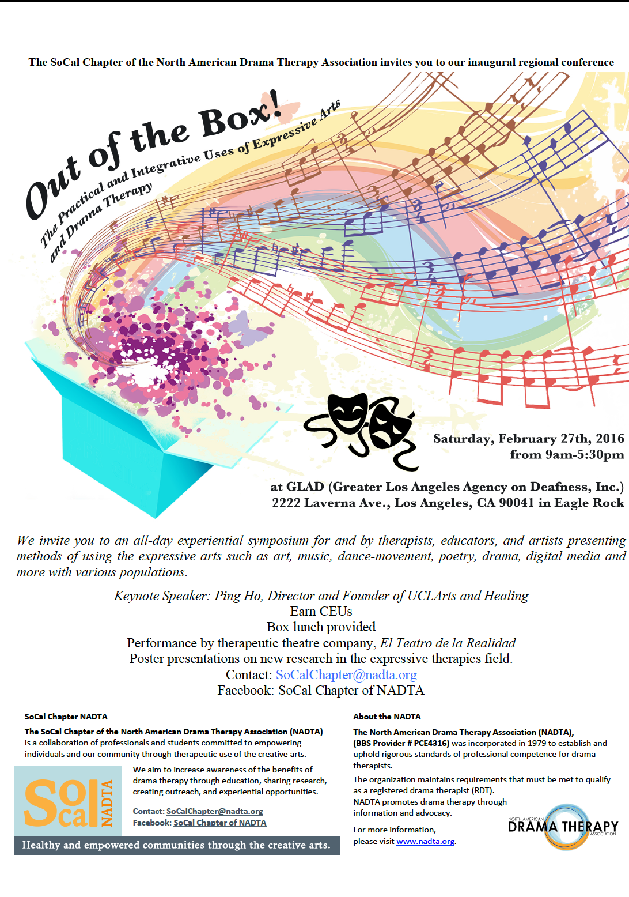

Regional Symposium (7 CE’s) Saturday, February 9th, 2019
"The Power of Playback Theatre and Drama Therapy: Therapeutic Tools for Witnessed Healing"

Keynote: Armand Volkas
Greater Los Angency Agency on Deafness (GLAAD), Los Angeles, CA

With The Living Arts Playback Emsemble
Trisha Jauchler, MS, MA, RDT/BCT,CT, CBF, CDP
Cynthia Holloway-Kelvin, Psy.D., RDT
Danielle Levanas, MA, LCAT, RDT
Perie Longo, PhD, LMFT, PTR
Kristy Pace, MA
On flyer (note Memberclicks link & required NBCC logo and NADTA logo)
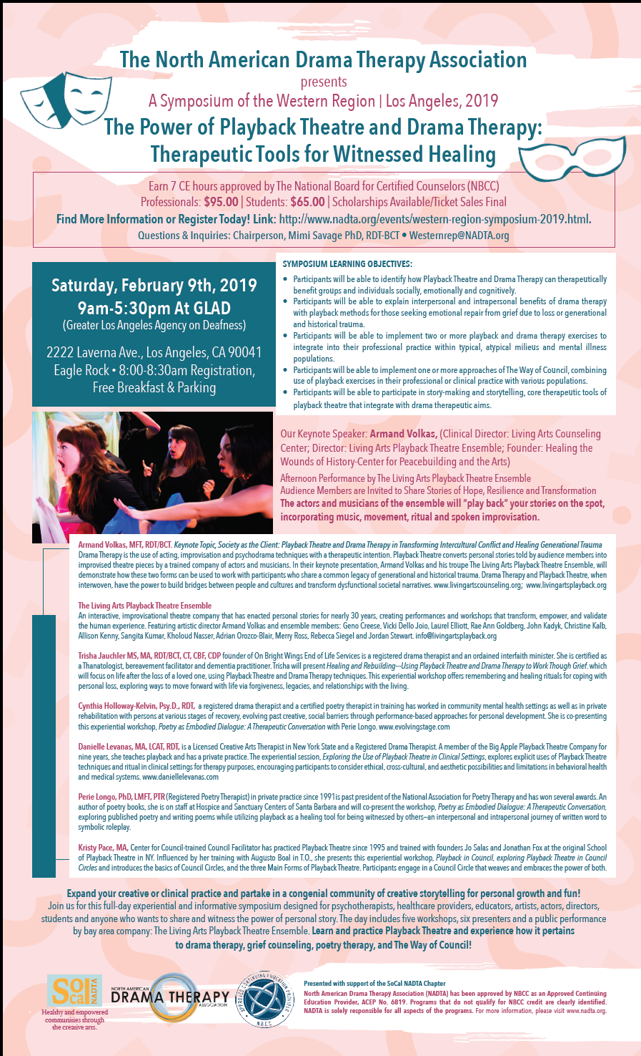

Regional Symposium May 11, 2019
Drama as Therapy and Theatre for Change during Challenging Times: A Symposium for Multiple Practices
Portland, Oregon

On flyer (note Memberclicks link & required NBCC logo and NADTA logo)
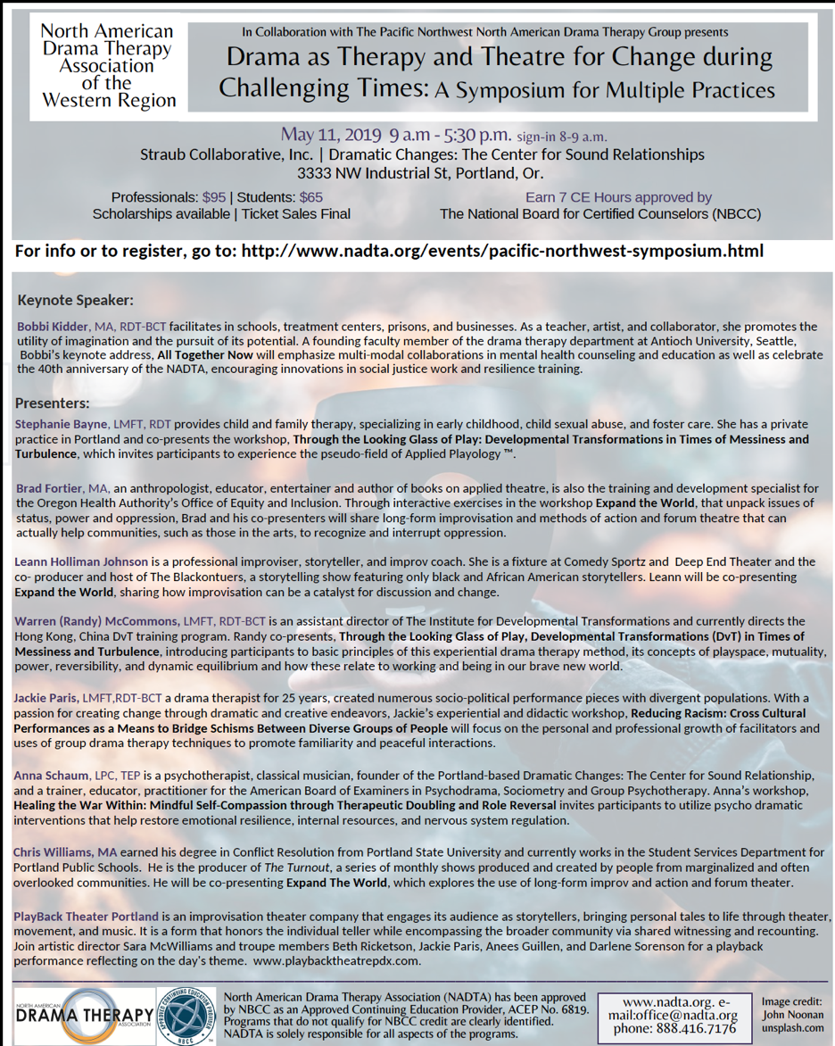

Presenter Series
Unique to SoCal are events that feature two or three Presenters (one is a drama therapist and the other(s) can be another CAT practitioner/experts in the social sciences field) who share their expertise in lecture form and experientially. Examples have been the Chair of the Clowning Dept at USC (the only program in the nation) for an experiential workshop; one of the lead authors and facilitators of Boal and T.O.; the chair of the dance department who is a somatic movement expert at Cal State Univ. LA; a DMT whose expertise is in mindfulness; etc;
- These workshops are geared toward those clinicians, students and professionals who can benefit from the knowledge shared and CE’s we offer through the NADTA via the NBCC (see protocol for regions offering CEs in this manual). The Presenters Series usually take place two or three times anually at an affordable venue known for artistry and events. Each regional group member knows the role he/she/they play for seamless hosting of the event as they have produced the events now for several years..
- The Presenter’s Series are advertised through the regional NADTA group’s mailchimp account, where they now have generated addresses from previous attendees and sponsors, free local internet list serves such as LACN (LACulture.net) or a paid account via MEET-UP on the internet.
- The Presenters Series usually occur on weekend days from 1 pm-4 pm and offer 3 CEs via the NBCC.

Examples and Flyers of SoCal Presenter Series
Each example provides a Date, Title of Workshop. List of Presenters, and Presentation Location

Presenter’s Series December 14, 2013
“Discovering the Expressive Arts”

Jeffrey L. Jamerson--Expressive Remix Workshop:Using Digital Media Art as a
Therapeutic Intervention with Children and Adolescents
Eagle Rock Center for the Arts, Los Angeles, CA

With Sherry Diamond
Multiple Role Identity: An Interdisciplinary Practice for an Interdisciplinary Life.

Presenter’s Series June 8, 2014
"Movement, Contact, Social Justice: A Dialogue in the Service of Expressive Arts Therapies"

Dr. Mady Schutzman Electric Lodge, Venice, CA

With Dr. Seónagh Odhiambo
Bradford Bancroft, MFT, RDT

Presenter’s Series April 11, 2015
"Communities in Action: Healing with Drama Therapy and Therapeutic Performance"

SALLY GORDON, LMFT RDT
Eclectic Company Theatre, Valley Village, Los Angeles, CA

With Kamran Afary, Ph.D.
And Joe Quintero--teaching artist, artistic director

Presenter’s Series October 4, 2015
"Research Using Visual, Digital Media and Expressive Arts Therapies"

JOSH COHEN, Ph.D
ARC - A Room to Create, Pasadena, CA

With DANIEL DOYLE, LMFT, RDT
MIMI SAVAGE, Ph.D., (Expressive Therapies), RDT

Flyer: Presenter’s Series (note flyer template; Memberclicks link & required NBCC logo and NADTA logo)

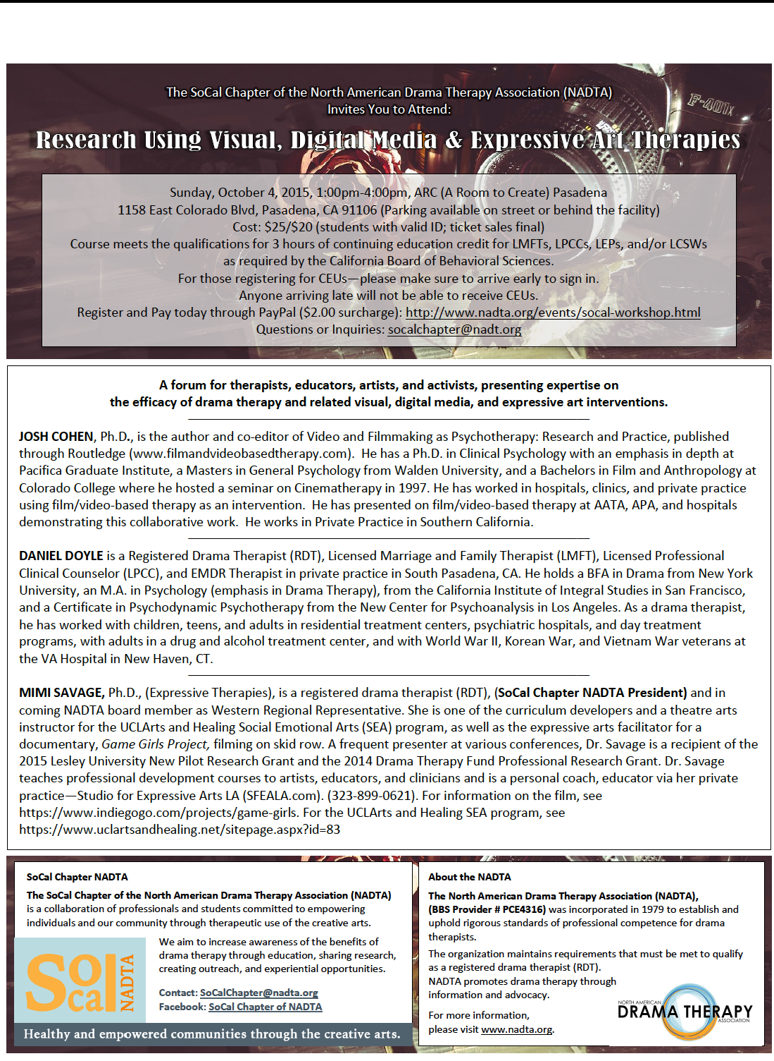
Presenters Series Sunday, October 2, 2016
"Playing the Unplayable: Healing Through Creative, Therapeutic Interventions"

Rachel Brousseau, LMFT, RDT
ARC - A Room to Create, Pasadena, CA

With Daniel Doyle, RDT, LMFT, LPCC, Certified EMDR Therapist
With Zach Steel Chair Theatre/Clowning Dept. USC
Flyer: Presenter’s Series (note Memberclicks link & required NBCC logo and NADTA logo)

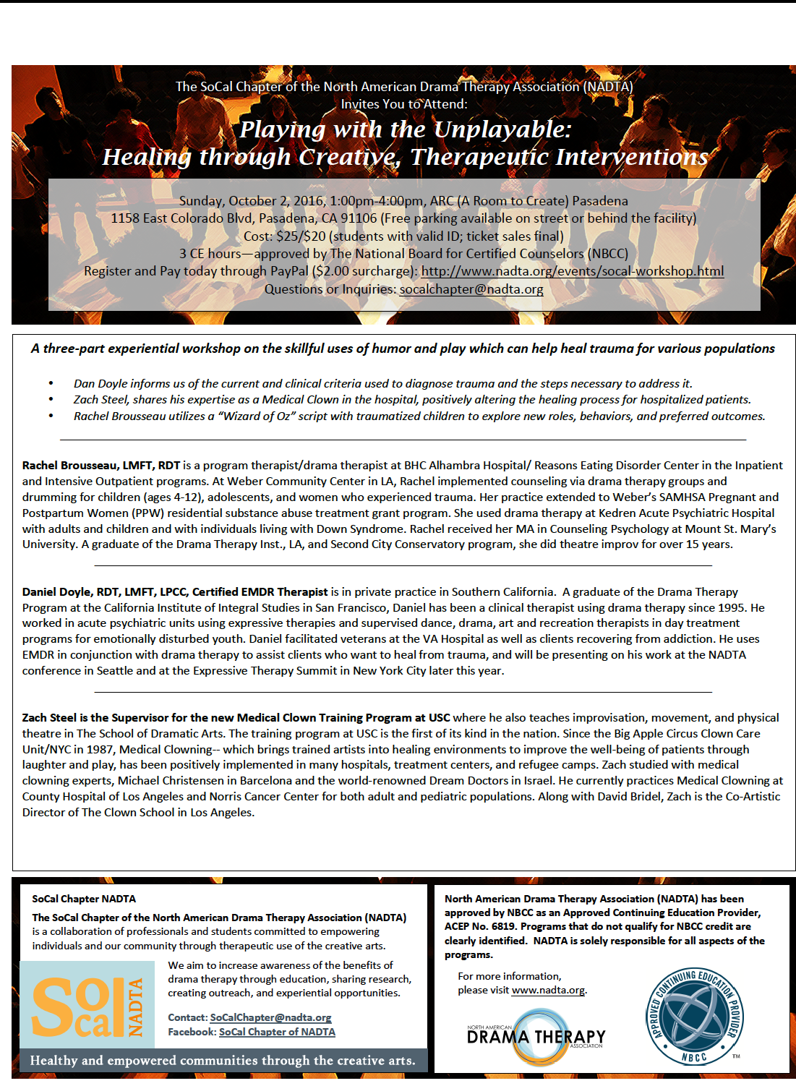
Presenter’s Series Sunday, November 19, 2017
"Self-Care: Reducing Stress and Developing Mindfulness Through Drama and Expressive Arts Therapies"

Kathy Cass, MA, BC-DMT, NCC, C-IAYT, AHC
ARC - A Room to Create, Pasadena, CA

With Daniel Doyle, MFT (MFC #40024), RDT
Jennifer Stuckert-Knapp, MFT (#86073), RDT

Presenters Series Sunday, May 20, 2018
"Act Now! Drama Therapy and Social Justice"

KAMRAN AFARY, Ph.D.
ARC - A Room to Create, Pasadena, CA

With Elizabeth Malone, MFA
SALLY GORDON, LMFT (MFC 44386), RDT

Presenter’s Series ( 3 CE’s) Sunday, May 5, 2019
"Exploring the Mask Within:Externalizing Shame through Drama Therapy"

Danielle Levanas, MA, LCAT, RDT
ARC - A Room to Create, Pasadena, CA

Intro to Drama Therapy Public Workshops
This group workshop is usually led by two drama therapists who may come from different trainings and is geared toward the layperson or public.
- There are no CE’s offered and these experiential workshops offered seasonly throughout the year bring insight to the public who may want to seek therapy or seek an education in drama therapy.
- The attendees find out about the workshop via MEET-UP, an online service that allows the public to generate group gathering based on mutual interests and via LA Culture.net, which is a free group yahoo account that anyone can request that announces all things artistic in Los Angeles county and beyond. It is a resource for listing events, classes, materials and employment for free. The SoCal Regional group uses regularly and links the NADTA sign up and registration for event payment on this internet vehicle. The only restriction is that the listing follow protocol and must be non-profit, free or an opportunity for employment.

Flyer 1. Introduction to Drama Therapy (note Memberclicks link required NBCC and NADTA logos & re-usable flyer template)
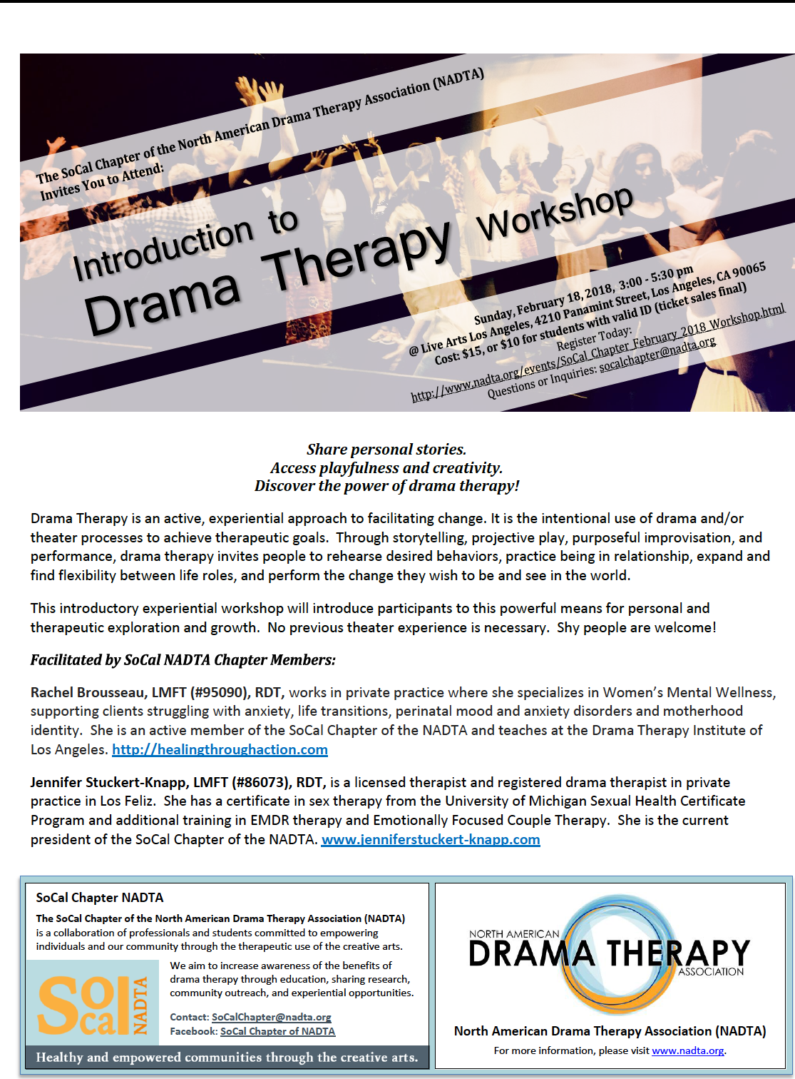

The Nuts and Bolts of Creating Workshops: SoCal Dialogue
As added information from one of the active Western regional groups which was once a chapter, I have asked the former chapter president of SoCal Regional NADTA some questions that may inform your prospective western regional group on how to create a successful coalition of people.
Dialogue between Western Regional Rep and the now SoCal NADTA Group Leadership:
- Mimi: Can you give me a breakdown of what the Intro to Drama Therapy Workshops catered to the public entails please? What about the space?
- Rachel: We have used a variety of spaces from dance studios to group therapy rooms. Any space where there is room to move.
- Mimi: What is the activity?
- Rachel: We start with welcoming everyone and reminding them that it is an educational workshop, not therapy. Giving our ethical explanation reminding clients to share only what they feel comfortable and take care of themselves. Then we do the structure of what a drama therapy group looks like guiding participants through warm up, central activity, de-role, reflection/conclusion.
- Mimi: The audience--how do you get them to attend?
- Rachel: We have been most successful in getting participants through MeetUp and Therapist Listserves like LACAMFT. We post our events to the chapter facebook page, but that doesn't get much traction.
- Mimi: Who leads the workshops?
- Rachel: It varies each time. We always have two facilitators that volunteer through one of our chapter meetings when we are figuring out who will do the next one. We have a date set at that point.
- Mimi: How do you decide who leads in the workshop for instance?
- Rachel: The two facilitators running the workshop will connect before the workshop to discuss planning the workshop, sharing ideas and deciding who will do what piece.
- Mimi: What is the fee for audience to attend?
- Rachel: $15/$10 students
Mimi: The cost for space?
- Rachel: Typically around $70-$75. Varies with the space.
Mimi: What is the time allotted for the workshops?
- Rachel: The workshop is 2.5 and we add 30 minutes for setup and 30 minutes to breakdown/answer any final questions
Mimi: What is the turnout --approximate numbers?
- Rachel: Approximately 4-10 people attend.
Mimi: The results of the turnouts--feedback from participants?
- Rachel: Feedback has been positive. We get participants from all kinds of areas such as actors, storytellers, therapists and teachers.
Mimi: What is the point of the workshops--why do them?
Rachel: To educate about what drama therapy is through experience. We don't make money from them. In fact, we're pretty happy if we break even.
Mimi: Anything else?
- Rachel: All events are posted on the NADTA website for participants to sign up in advance. We use an electronic flyer when we send out to list serves so people can sign up and pay in one step through the NADTA website. There is a link on our flyer. We use it now as a template and just change up the dates and info on the flyer each time we send it in to the office to get it linked up to the NADTA website. FYI: It is recommended to have a third person checking people in at the door of the workshop. People can pay at the door also. We have a square account connected to the NADTA if someone needs to pay by card.
- Mimi: You use Meet-up. What about your cost for ads in Meet-up?
- Rachel: MeetUp is a membership site so it doesn't cost to post each event. I believe the cost to initially sign up is around $69 and then I think it's $99 each year after.
Mimi: What about your group’s mailchimp account? Cost? Usage?
- Rachel: MailChimp is free. We haven't used it yet to promote Intro to Drama Therapy workshops.
Mimi: Do you offer CE's for the Intro to Drama Therapy?
- Rachel: No.
Mimi: How do you get your attendees?
- Rachel: SoCal Chapter email list, listserves, facebook, asking chapter members to personally invite 2 people they know
Mimi: You have another signature workshop that offers CE’s. How and where is the Presenter’s Series workshop organized now?
- Rachel: At the same location each time (ARC in Pasadena). We have a good deal there and someone in the arts who owns the space--a dance studio and entertainment facility who supports our vision. At Presenter Series events, someone is at the door, helping people sign in and sign in for CE's. Someone else is supporting by taking money. Two people present on two separate topics that relate to the theme and title. Of the two, one is a licensed individual through the BBS who is also a creative arts therapist. More information is gathered about the presenters to be kept on file than Intro to Drama Therapy workshops and advertising must be done a certain way per the NBCC standards. A 10-15 minutes break occurs in between presenters. We provide a two sided program per the NBCC rules of offering course objectives, bio and workshop description for the event as well. We send the CE’s electronically to licensed practitioners after the event. Someone is the point person for that. It’s fairly easy for us now that we have done it so many times.
Mimi: What is the cost and profit of that series?
- Rachel: The space is 25.00 to 30.00 per hour for the 4 hours. We get free use of projector, seats, tables and projector screen. We purchased our logo table banner and logo stand as well as some black table cloths (fabric district) for cheap a few years ago and bring those each time. We offer coffee from a large urn we own, hot water for tea from the kitchen, and we bring snacks like baked cookies. We also advertise our businesses on tables in the entrance and offer NADTA info via brochures.We hold a raffle usually for an appropriate book we get for cheap. The event time is from 1pm to 4 pm and we have time for set up and clean up, but attendance ranges from 15-40 people with an average of 20 so the profit outweighs the cost. The event is three hours but we rent for 4 hours and tuition for attendees is $25 for professionals and $20 for students. We have not raised the price in all the years.
- (October 28, 2019)

Template: Organizing the Planned Three-hour Workshop Day

Presenters’ Series (3 CE’s) SoCal Regional NADTA Group
Time Schedule: June 8, 2014
Electric Lodge
Guests: Mady Schutzman; Seonagh Odhiambo Horne

- Regional NADTA Groups members will be arriving to set up at the space at 12:00 (not open to public) free parking/all equipment needs etc will be pre-set and are minimal—(PRE-SET stage, projector and tables—30 minutes)

- 12:30 AUDIENCE ADMITTED INTO SPACE (coffee, etc offered) Attendees sign in for CE’s at Front Desk

- 12:45 or 12:50-1:00---intro to the Group leadership welcomes guest and presides--introduction to speakers & other announcements/consent and release for video or photo/CEUs reminders
- 1:00-1:10---warm up icebreaker (Horne leads)
- 1:10- 2:10---Mady Schutzman presents (1 hour) (STRIKE projector)
- 2:15-3:15---Seonagh Odhiambo Horne presents (1 hour) (SET UP; I-POD for music)
- 3:20-3:40---Bradford Bancroft with audience discussion (20 min)
- 3:40-3:50--Q & A further open discussion with all presenters (10 min? or less) 3:50 END
- Closing: Attendees sign out for CE’s and Evaluation Sheets for pick up
begin clearing papers and projector, etc…things not needed for final minutes
- 3:50-4:00—pickup forms/audience opportunity to gather info in space/CLEAN-UP (10 min.)

Aiding Western NADTA Regional Groups
Currently, there are a few working Regional Groups (previously Chapters) within the Western Region. It will be the responsibility of the Western Regional Rep to provide guidance to these groups.

SoCal Regional NADTA Group:
Unique to this regional group is the existence of their past six years as a functioning chapter that produced several events (see listings in this section). They have also generated income so they can continue to produce the events they desire. The group’s concept and philosophy is that drama therapy needs to be open to the community and not just for drama therapists and they believe the group needs to support its members and grow membership in active ways that involve other CATS and professions.
- The regional group members meet every month or every other month on a Sunday and attend to the insular needs of the group at those meeting inclusive of check-ins and experiential exercises.
- They plan on public events and member gatherings at their meetings as well, with the goal of supporting each other, drama therapy, and the business of drama therapy in their locale. Occasionally, they meet via ZOOM because SoCal is so large and it becomes a challenge to meet in person. They also alternate on member meeting locations.
- The philosophy behind the larger function of the group with the Presenter’s Series that they put together is to build bridges with other Creative Art Therapists (CAT)and with the Introduction to Drama Therapy Workshops--it is to inform the public and other clinicians who may be curious about drama therapy.
- The regional groups do educational outreach individually or as a group.
- They offer NADTA brochures at each event /lecture/workshop they do as a group as well as offer their own private practice business cards and flyers.
- They invested in a professionally printed table banner and full-length stand-up banner for a professional look and created their own SoCal logo that also features the NADTA logo. They have also created their regional mission and vision statements to help solidify their unique goals as a group in this particular region.

The Pacific Northwest Regional NADTA Group:
The group has been headed by two RDTs in Portland Oregon who continue to want to support local applied theatre artists and drama therapists in the region. This is unique to their city and group. They have also affiliated with nearby Antioch University. After several meetings with small but interested discussion turnouts in the Portland area in free or cheap creative spaces, they have chaired their first conference in 2019. The regional rep allotted monies for these meetings to purchase coffee and snacks and for affordable rent during the smaller meetings that led up to the larger inaugural conference.
- The first Pacific Northwest Conference/Symposium under the NADTA was executive chaired by the Western Regional Rep. The local, onsite work and day to day was in the hands of the two RDTs in good standing who are NADTA members, who were the Co-Chairs who began this Regional group three years prior to the event.
- The one day, all day Symposium featured drama therapists and non-drama therapists ( see flyer for the event in this section).
- Students from Antioch University’s drama therapy department and other locals volunteered and were able to do ticket sales, breakfast service and other duties
- The large professional spaces belonged to a presenter who is a psychodramatist who volunteered the space as long as it was insured (please see info in the resources section of this manual about large event one-day liability insurance which is essential and cheap). The NADTA annual conference insurance coverage does not insure regional events. If you have large turnouts of attendees, this is necessary. There were 75 attendees.
- The attendees enjoyed a food truck offering for lunch and affordable brown bag lunch sandwiches in a great venue.
- The keynote featured a well known, respected drama therapist
- The event offered 7 CE’s via the NBCC
- Antioch University Drama Therapy Department is currently committed to hosting the second symposium in Seattle at Antioch with the Western regional rep’s support. Their facilities are free as a venue. Attendees will come from all areas of the Pacific Northwest. The aim is for annual or biannual symposiums alternating from these two groups.

Part Four: Forming a Member-Led Regional Group

(Adjusted) Guidelines for Creating Regional NADTA Groups and Activities
Version 3, October 2019 (Guidelines for Regional Reps and Regional NADTA Groups)

Introduction:
The North American Drama Therapy Association supports the formation of local regional groups in each state in the U.S. and in provinces and territories in Canada. Guidelines provided in the Manual for NADTA Regional Representatives describe the tasks and responsibilities of our Regional Representatives, who are on the NADTA board and who have documented, approved resources about the NADTA mission, vision, and its ethics, inclusive of diversity, as well as its Scope of Practice to guide them. Chapters will no longer be formed, making previous chapter by-laws defunct. Rather, Regional NADTA Groups are now formed by members in a region within a state or province with the assistance and approval of their Regional Representative. NADTA Regions with the support of their Regional Rep can hold regular meetings and events to support drama therapists, students, and others interested in the field of drama therapy.

Objective(s):
- To ensure that all communication and functions for events remain consistent between the Regional NADTA Group, Regional Rep, the NADTA Executive Board, the NADTA office, and Treasurer. The point of contact for all Regional Groups is the Regional Representative. To keep the lines of communication clear, the Regional Rep will contact and communicate to the Board and NADTA office for the Regional Group about their needs and concerns. The Regional Representative represents the NADTA groups within each state or province and offers final approval (with the support and knowledge of the executive board and other board members if necessary) on their actions in order to facilitate and fund events.
- To ensure that regional events are posted, promoted, and handled appropriately within the scope of the NADTA and its manualized guidelines.
- Titles of Regional Groups/Communities: Per the enclosed documents in this manual, regional groups sponsored by NADTA are called Regional NADTA Groups. Previously designated NADTA Chapters are defunct. Instead, previous chapters can now have such titles as: SoCal Regional NADTA Group, Pacific Northwest Regional NADTA Group, Colorado Regional NADTA Group, Tri-State Regional NADTA Group, Texas Regional NADTA Group, Midwest Regional NADTA Group. Per their decision, they may narrow their identity to a specific city or grouping such as New York Regional NADTA Group, San Francisco Regional NADTA Group, Montreal Regional NADTA Group, or DvT Portland Regional NADTA Group, Kansas City Regional NADTA Group, Minneapolis Regional NADTA Group, etc.

In this portion of the manual, the following items will be covered:

- How to Figure Out If There Is Support for a Regional NADTA Group
- Application Information to Form a Regional NADTA Group
  - Regional NADTA Group Name and Goals
  - Agreements and Signatures
- Guidelines for Regional NADTA Meetings
- Information for Groups to Create a Regional Event

How to Figure Out If There Is Support for a Regional NADTA Group

What to do.
- Search memberclicks for a list of NADTA members in your region or who work in a particular interest area. (contact the office or membership chair for instructions.)
- Talk to others to gauge interest and commitment.
- Contact NADTA members in your region via email. (This is done through the office or regional Representative Board member.)

Do we need bylaws? No. Regional NADTA Groups are part of the NADTA and are covered under Article XVI of the NADTA by-laws. Regional Groups are under the supervision of a Regional Representative although members should articulate basic leadership roles and functions according to their needs or the needs of their event.

What do we need to start a Regional NADTA Group?
- Read through this section.
- Identify members in your region and determine whether there is sufficient support.
- When needed, read the Regional NADTA Group Financial Procedure Document – available from the NADTA Treasurer at: treasurer@nadta.org.
- Notify the NADTA Board of your interest by emailing the Regional Representative initially and CC president@nadta.org, presidentelect@nadta.org, membership@nadta.org, office@nadta.org, treasurer@nadta.org Regional Representative’s emails are as follow: (easternrep@nadta.org,centralrep@nadta.org, westernrep@nadta.org or canadianrep@nadta.org.
- Complete an application form and submit to the NADTA Regional Representative and President at least 3 weeks before the Annual NADTA Conference or Annual Board meeting in the spring (May-June). When the Board meets, they will review your application at that time.

Do I need to start a Regional NADTA Group to have a Regional Conference? No. Contact your Regional Representative to discuss setting up a regional conference or other event, which can take place on-line or onsite and can offer CEs to NADTA members and other professionals.

Required Regional NADTA Group Roles: Members of a particular Regional Group may be RDTs, drama therapy students, interns and other professionals who are paid members of the NADTA. Note: This is an adjustment that changes the criteria and protocol of previous chapter structures. Roles are more loosely defined and events can be produced without regional group affiliation. All processing of groups and/or events must go through the Regional Representative.

As a SUGGESTION, Useful Roles for A Regional NADTA Group Can Be:
1. Meeting Coordinator--Organizes meetings and helps documents minutes. Meets online and/or onsite.
2. Finance Point Person onsite – Liaises with Regional Rep who budgets and provides financing and monies through the NADTA Treasurer and office.

Additional Roles that MAY be Needed
3. Publicity
4. Social Media
5. Events Coordinators
6. Student Liaison
7. CE Coordinators—Liaises with Regional Rep & CE Committee to follow CE protocols for events (info in manual)

Please Note: Regional NADTA Group roles and jobs can be defined and articulated by the groups themselves, according to their unique needs, long-term, short-term goals, missions and visions. The Regional NADTA Group members can determine (with Regional Rep. & National Board approval) the length of time they facilitate in their roles and shared responsibilities within their group.

Basic Procedures: Follow the Regional NADTA Manual
- Email the Regional Rep first on all questions and documentation. Then CC the following for all meeting minutes, emails to members, budget/financial needs and requests to: office@nadta.org, president@nadta.org, presidentelect@nadta.org, or membership@nadta.org (if an interest group)
- Support for local or Regional conferences is through the Regional Rep. initially and sometimes through the vicepresident@nadta.org.

Application Information to Form a Regional NADTA Group

Application to Form a Regional NADTA Group
INFORMATION AND INSTRUCTIONS
Purpose of this document:
- Articulate functions of Regional NADTA Groups.
- Serve as application to the NADTA Board for approval to start a Regional Group.
- The signed, approved form serves as an agreement between the Board, the Regional Representative and members of a Regional NADTA Group regarding responsibilities.
This document is for NADTA members who are interested in forming a Regional NADTA Group in a particular region—specific state or province of North America.

PLEASE NOTE: The Membership Chair (membership@nadta.org) and Regional Representatives are available for questions and support. To determine your region, email membership@nadta.org.

REGIONAL NADTA GROUP NAME AND GOALS
______________________________________________________________________________

Application for Regional NADTA Group

Proposed Regional NADTA Group Name: (i.e Pacific North-West Regional NADTA Group, SoCal Regional NADTA Group, etc)

Local/Regional or Area or Interest Group Served:

Names of current NADTA Members who have expressed willingness to
support the Regional Group with dues and volunteer time. Attach additional pages if needed:______________________________________________

The Group Mission, Vision and Goals are the same as the North
American Organization as stated on the NADTA website. The Group may have
the following unique additional local/group mission, vision and goals:_______________________________________________________

NADTA MISSION
To support and advance the profession of drama therapy.
NADTA VISION
Enhancing the quality of life for individuals, families, and communities through supporting and educating drama therapists.
NADTA VALUES:
- Creativity and innovation in healing
- Professionalism, integrity, and ethical accountability of practitioners
- Inquiry, research, and transparency of communication
- Collaboration, compassion, and community building through the drama therapeutic process
- Creative alignment between values and action
- A commitment to inclusiveness, a promotion of diversity and cultural competency within the drama therapy community and the clients we serve.

a) Regional NADTA Group Supplemental/ Helpful Forms

- Lead Meeting/Event Coordinators (may be more than one person) NADTA Group members are in good standing, maintain membership in the NADTA.

Name of person/persons selected to hold this position:__________________________________________________

Job Description:____________________________________________

NADTA Membership Status: (i.e.RDT, drama therapy student, dt intern, ATR, DMT,IEATA,TEP, MT, LMFT, SW, OT, etc.______________________

- Finance Point Person (can be more than one person)

Name of person selected to hold this position:__________________________________________________

Job Description:Liaison with the Regional Rep and NADTA Treasurer about event financing,
reimbursements and payment of liability insurance (if hosting an event).

NADTA Membership Status: ________________________________

- Publicity/Media
Name of person selected to hold this position:___________________

Job Description:___________________________________________

NADTA Membership Status:_________________________________

- CE Coordinator

Name of person Selected to Hold this Position:__________________

Job Description:___________________________________________

NADTA Membership Status: ________________________________

- Additional Group Roles/Jobs?

Name of person Selected to Hold this Position:_________________

Job Description:__________________________________________

NADTA Membership Status: _______________________________

- Additional Group Roles/Jobs?

Name of person Selected to Hold this Position:__________________

Job Description:____________________________________________

NADTA Membership Status: _________________________________

b) Group Membership Protocols/Roles

1. Members will serve in roles determined by their unique needs. They can document roles/dates they begin membership _________________ (date) and end ____________________ (date) their group and/or various roles they hold in the group:________________________.

2. Roles in Groups will be selected by fair consensus and determined by the Group members.

3. There will be no need for elections that follow previous chapter protocols.

4. There are no set term limits except for the role of Regional Rep who facilitates Regional Groups.

5. A Regional NADTA Group consists of at least one RDT or student on track to becoming an RDT and other individuals who are up-to-date paid NADTA members.

c) Group Decisions To Consider

1. Is there a meeting protocol (such as Robert’s Rules of Order)

2. How will the Regional Group make decisions? (Consensus, majority vote, etc?)

3. The Regional Representative is responsible for managing the budget. The Regional Rep needs to be consulted in a timely manner on financial needs.

4. Requirements for membership and NADTA benefits including event funding: Must be NADTA members in good standing.

5. Will the Regional Group want to supplement the mission and vision of the NADTA, which they will incorporate in any event or print material they publically share, with their own local needs via a mission and vision? This may create a clear direction for a group to follow as they coalesce. For instance, the SoCal Region created their impetus for creating a group with a mission and vision and logo they use along with the NADTA logo
- Mission: The SoCal Chapter (now Regional Group) of the NADTA is a collaboration of professionals and students committed to empowering individuals and our community. Through therapeutic use of the creative arts, we aim to increase awareness of the benefits of drama therapy through education, sharing research, creating outreach, and experiential opportunities.
- Vision: Healthy and Empowered Communities Through the Creative Arts.

Agreements and Signatures

Regional Group Members Agree to the Following:
1. Regional Group Members agree to act in accordance with the NADTA Mission and Goals.
2. Regional Group Members have read and agree to all policies and procedures posted in Memberclicks .
3. Regional Group Members agree to maintain compliance with laws governing 501c6 corporations under the State of New York Department of Education. This includes reporting all income and financial transactions to the NADTA Board. (The term NADTA Board referring to the North American Board or National Board.)
4. Regional Group Members are required to maintain current membership in the NADTA and the Chapter.
5. Regional Group Members understand that any fundraising initiatives or research initiatives must be approved by the national board through their Regional Representative.
6. Regional Group Members understand that the Group is not a separate legal entity from the national organization, but is legally part of the organization.

Promotional Materials, videos, newsletters, publications, social media:
7. Regional Group Members agree to comply with all copyright laws in the use of any media, music, images, video or photocopies that the Group uses.
8. Regional Group Members agree to submit promotional materials created by the Group to the NADTA Board for feedback and approval before publication. This includes, but is not limited to: videos, brochures, calls for papers and conference materials.
9. Regional Group Members agree to the NADTA social media and technology policies which include listing the National President and Communications Chair as Administrators on all accounts, listerves or groups that serve as communication for the regional group and/or list NADTA, NADT, National Association for Drama Therapy or North American Drama Therapy Association in the title or description.
10. Regional Group Members agree to follow the Behind the Scenes publication principles in the use of case material in any Regional Group publications.
11. Regional Group Members agree to obtain appropriate consent from the subject in the use of any photos and other media.
12. Regional Group Members agree that flyers or newsletters provided by them must represent the image and mission of the NADTA as well as Regional Group information approved by the Regional Rep and the Board. Due to potential liability issues, if additionally advertising their personal businesses or events on printed materials such as a local newsletter etc, Regional NADTA Group members must make clear that the NADTA is not endorsing personal or private practices to the public.

Financial Procedures:
13. Regional Group Members agree to submit a budget for their events through their Regional Representative to the NADTA Board each November for the following year and to submit updates on their Group activities and budget-to-actual reports at least 2 weeks in advance of each North American Board meeting in the Spring and Fall and as requested by the NADTA Treasurer or President. (This may be requested for a quarterly Board Conference call if the budget is on the agenda.)
14. Regional Group Members agree to the Financial Procedures posted on the NADTA website and in the regional manual.
15. Regional Group Members understand that a timeline and budget must be submitted and approved by the national board through the Regional Representative before any major event can be scheduled. A major event is defined as a conference or an event with a budget exceeding $250 and anything involving pre-registration or ticket sales.
16. Regional Group Members understand that receipts must be submitted during the calendar year incurred to the national Treasurer through the Regional Rep. for all expenses in order to be covered or reimbursed. Regional Groups cannot be reimbursed for expenses that exceed their current funds balance. Receipts must be submitted to the Regional Rep in the calendar year incurred or within 30 days of when the expense was incurred – whichever is later. Late requests for reimbursement may not be honored.
17. Regional Group Members agree that expenses exceeding $150 must be submitted in the budget or pre-approved by the National Treasurer and Regional Representative.
18. Regional Group Members understand that the National Board must review and approve any contracts before they are signed. The liaison for this is the Regional Rep.
19. Regional Group Members understand that the group will be required to carry insurance for events such as conferences.
20. Regional Group Members understand that the group is responsible for all expenses and fees incurred by the Group, including costs to the NADTA organization paid on behalf of the group - including, but not limited to: bank fees, credit card fees, phone calls, Regional group mailings, equipment damage, insurance premiums and office support.
21. Regional Group Members may also be asked to contribute or assist in raising funds for local or state-based initiatives that benefit members in their region.
22. Seed money for Regional Events can be made available to the Regional Group with prior request. These requests need to go before the Regional Rep twice per year. Requests for seed money should follow the guidelines for Regional Event (listed under Part 2 of the manual).

Other Social Media Procedures:
23. Support for sending emails and mailings will be available to the Regional Groups. Emails can be sent to NADTA members by sending the text to your Regional Rep or NADTA Office and allow up to a week for the email to be sent. Please indicate if you want the email sent only to paid Regional Group Members or if you would like to include all members in a given state(s) or region. Please allow up to one week for the email to be sent. (Note that office support for postal mailings may need to be coordinated through the NADTA President and President-Elect to coordinate with national office demands –particularly during busy times of the year such as during national conference deadlines.) Note that costs incurred by Regional Group mailings will be covered by the regional group and paid via the Regional Rep.
24. Regional Group meetings and events will be listed on the Events feed at the nadta.org home page and on the events calendar.
25. Each Regional Group will be given one email address____ @nadt.org at no cost to the group. The Regional Group is responsible for managing this email account. If more email addresses are needed, they can be made available with the Regional Group covering the cost of additional email boxes ($5 per month for up to 5 emails as of 2013.)
26. Regional Group members will be given access to resources of the NADTA as appropriate and when possible.
27. Regional NADTA Group members will be given space in Behind the Scenes to write about the group and its members.

All Regional NADTA Group members Please sign and date below:

_______________________________________________________________________

_______________________________________________________________________

_______________________________________________________________________

_______________________________________________________________________

_______________________________________________________________________

_______________________________________________________________________

The NADTA Board and NADTA Office agree to the following:

The North American Drama Therapy Association voted favorably on ____________ (date) to approve the formation of __________________________________________________ (Name) Regional NADTA Group.

President:_________________________________________________________________

President-Elect:_____________________________________________________________

Secretary: _________________________________________________________________

Treasurer: __________________________________________________________________

Regional Representative: ______________________________________________________

Guidelines for Regional NADTA Meetings

Communication:
- The Regional Representative will be the direct contact for all Regional NADTA Group concerns and will contact the board or the office on behalf of the Group.
- For purposes of clarity, the Regional Rep will be that point person but will CC Regional NADTA Group members in those correspondences.
- Note the Group will be assigned an email address as follows: namegroup@nadta.org This should be used for all official communications for the Group. Questions about accessing or forwarding this email address can be directed to the NADTA Office.
- A Lead Coordinator for the regional group will take minutes/summary at the regional group meetings and email them to the Regional Rep, CC the office and the President and President-elect.

Meetings:
The Regional NADTA Group members will meet at least twice per year and may meet more often as needed with their Regional Rep. Meetings may be held onsite or by phone or skype/gmail if members prefer.

Although the new format of Regional NADTA Groups does not require the formation of a formal group in order to create events. If a group of people do want to meet regularly and set up a particular mission or vision for coalescing, the forms for doing so are included in this manual. After the meeting, minutes/summary will need to be sent to the Regional Rep and cc’d to the NADTA office, the President and President Elect. The Treasurer will need to be contacted about funds needed and earned and the process will go through the Regional Rep. A point person will need to write the minutes for the group as well as attend to funding details.

This is an example of what an itinerary and/or minutes may look like for a group:

- SoCAL NADTA Group Meeting - 6/12/16

- Welcome – Mimi Savage (Lead)
- Reading of Mission Statement – Dan Doyle (Secretary)
- Role Call: Mimi Savage, Kamran Afary, Dan Doyle, Jennifer Stuckert-Knapp, Jennifer Breslin, Cynthia Kelvin (via phone)
- Introductions of individuals in attendance
- Personal/Professional Check in

II. Western Regional update - Plans for Groups and Events

III. Financial Point Person Report (if needed)

IV. Communication Report (if needed)

V. Other Reports or Plans

VI. Next meeting plans and group goals before next meeting

Information for Groups to Create a Regional Event

Groups that are interested in creating a regional event should follow the guidelines and proposal requirements set forth in the revised Regional Model (Part 2 of manual). Ask your Region Rep about current proposal application and timeline to host an event.

Part 5: NADTA Regional Resources

SUPPLEMENTAL INFORMATION, USEFUL FORMS AND TEMPLATES

NBCC CE Provider Policy Content Guide

The next few pages will include the beginning portion of the NBCC Continuation Policy. Please contact the Vice President or Education Chair for more in-depth information concerning NBCC.

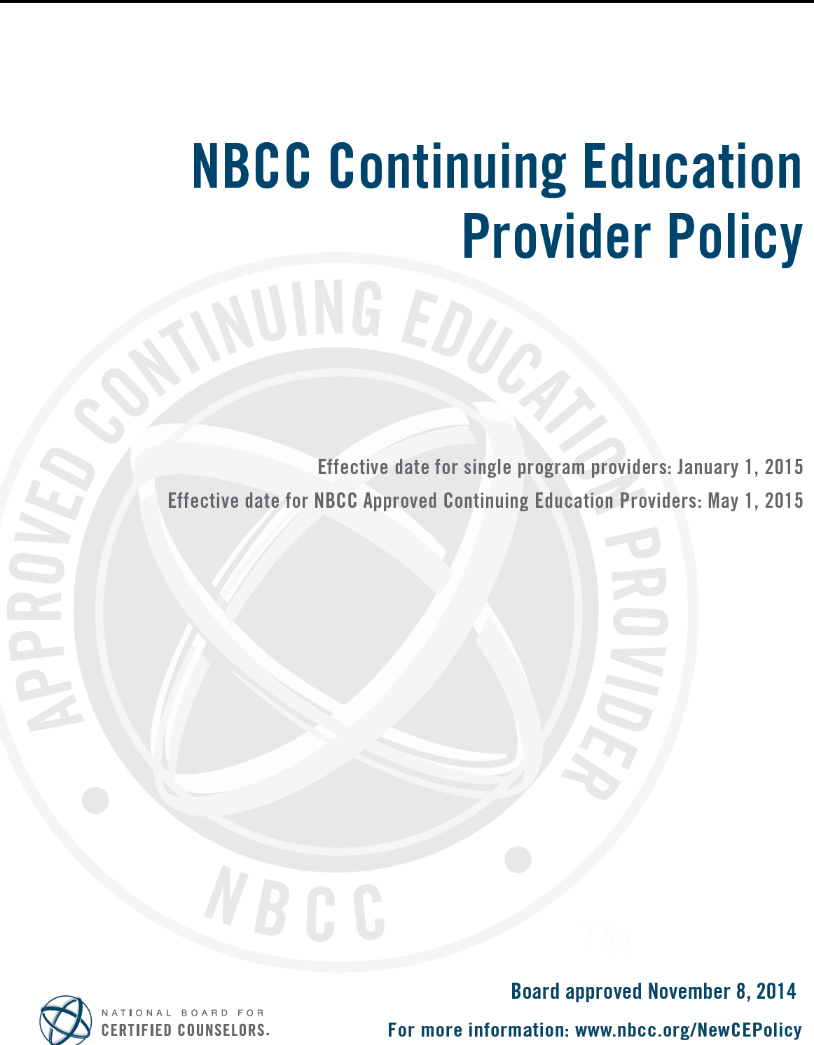
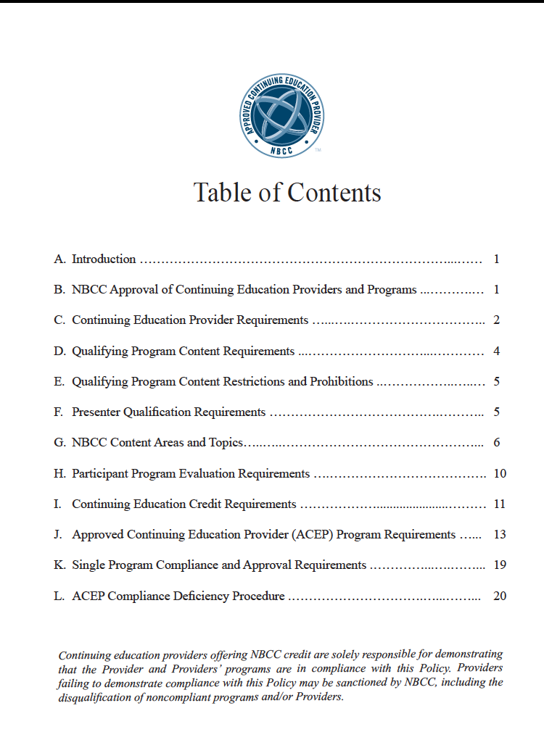

NADTA Approved Provider Reference Sheet / NBCC and NYS LCAT Continuing Education Activities

Note: this reference sheet does not provide all specifics and details about creating continuing education activities. Specific activities must be submitted to the Continuing Education Committee for approval. Questions should be directed to education@nadta.org. For further information please see NBCC Standards hereford NYS Department of Education guidelines here.
 | NBCC | NYS Dept of Education
What is it? | National Board of Certified Counselors | NY State Department of Education, Office of the Professions
Who uses these CEs? | A variety of state licenses/credentials allow NBCC CEs to “count” as continuing education, mostly counselors | Only NY State LCATs (Licensed Creative Arts Therapists)
Who can conduct the activities? | The NBCC has a 3-tier system for ranking presenters. The most stringent category requires presenters to:  “(a). Hold a graduate degree in a mental health field from a regionally accredited educational institution; and, (b). Be qualified by appropriate education, experience, and/or training to present/author the particular subject matter, or author the publication concerning the subject matter.” For some categories of presentation the education requirement is less specific, for details, see here on pages 5–10 | Generally, only LCATs, or LCSWs (Clinical Social Workers), PhD-level Licensed Psychologists, Psychiatrists, and Psychiatric Nurses [Non-LCATs should demonstrate training in creative arts therapies or specific training in the area of the continuing education.]  Note: there is some leeway for other providers to teach CEs on “non-clinical” topics of expertise, such as: administrative supervision of employees, case management services, data analysis, advocacy, management, and community organizing.
Activities can include | 1. Counseling Theory/Practice and the Counseling Relationship.  2. Human Growth and Development.  3. Social and Cultural Foundations.  4. Group Dynamics and Counseling.  5. Career Development and Counseling.  6. Assessment.  7. Research and Program Evaluation.  8. Counselor Professional Identity and Practice Issues.  9. Wellness and Prevention.  For information on what fits in each category, see hereon pages 6–10 | “Clinical interventions and evidence-based practice;  cross-disciplinary offerings from medicine, law, administration, education, behavioral and social sciences related to creative arts therapy practice, patient communications, recordkeeping, and matters relating to law and/or ethics which contribute to professional practice in creative arts therapy and the health, safety, and/or welfare of the public.  All subject topics must be comparable to those taught in professional education programs in creative arts therapy offered by a program that is registered under section 52.34 of the Commissioner’s Regulations.”
Activities cannot include | 1. The program content cannot be solely or primarily designed  or intended for: professions other than professional counseling; the general public; paraprofessional  counselors; or, any other individuals engaged in counseling or other mental health activities who are not  graduate-level professional counselors.  2. The program content cannot be solely or primarily concerned with  the medical or physical health of clients.  3. The program content cannot state or imply in any manner  that individuals who act inconsistent with, or who do not accept, a particular political or religious belief or principle are dysfunctional, or otherwise inappropriate, or that the belief itself is unacceptable or incorrect.  4. The program content cannot present or include information promoting Sexual Orientation Change Efforts as a therapeutic method. | “(a) Any continuing education designed for the sole purpose of personal development, marketing, business practices, and maximizing profits for the practice of a licensed creative arts therapist shall not be considered by the department as acceptable continuing education.  (b) Supervision of a licensed creative arts therapist, limited permit holder, student or intern in a placement that is part of a license-qualifying program, is not an acceptable subject of continuing education.”  Also: any classes taken to qualify for licensure in an another profession
Time boundaries and requirements | Always refer to “clock hour” or “contact hour,” never CEUs | A contact hour must be no less than 50 minutes of instruction. Any proposed course must be at least one hour in duration. Time spent during breaks, meals, etc., cannot be included in contact hours.  If you do not offer a break during a one-hour course, the learner does not earn more than one hour of continuing education credit. Similarly, a three-hour course may have a single break of 15-20 minutes; the course is still a maximum of 3.0 hours.
Course requirements | A course must have listed learning objectives, and there should be a documented process for testing/observing if those learning objectives have been met.
Documentation | Providers must utilize attendance and evaluation forms in accordance with NADTA guidelines and those forms must be sent to the NADTA office for processing and storage. Completion certificates are emailed to participants from the NADTA Office.
Does the instructor get CE credit? | No

NADTA LCAT/CE Request Form
The form for NY State LCAT CEs: see link or request info from Education Chair.
https://forms.gle/HVTKsQyN1wZ8dT3H6
Use this form to request the capacity to offer NY State LCAT CEs for your events.
The name and photo associated with your Google account will be recorded when you upload files and submit this form. * Required
Email address *
Your email

Who is sponsoring the event? *
Choose

What is the title of the event?
Your answer

When will the proposed event take place?
MM/DD/YYYY

What is the duration of your workshop? If there are breaks, please indicate how many and how long.
Your answer

If you have the proposal for the event already prepared in a word document or PDF, please upload the file here. Otherwise you can continue using this form to submit your proposal.
ADD FILE

Who are your presenters and what are their professional credentials? [For LCAT CEs Clinical presenters must have LCAT or [LCSW/PhD in Psychology and training in creative arts therapies]
Your answer

Where will your workshop take place?
Your answer

Describe the content of your workshop (Please use detail. Describe what attendees will do, not just "We will do drama therapy about this issue." It's okay if it isn't completely finalized, but please do give a sense of what participants could expect.
Your answer

What are the learning goals of the workshop? (Generally should be at least three. Make them specific to the topic at hand. [Examples: "(1) Participants will identify key challenges in implementing embodied exercies with clients who have disordered eating;" "(1) Participants will identify three specific strategies for self-care within their work environment;" "(3) Participants will have a chance to experience DvT Drama Therapy techniques in group and individual formats.")
Your answer

What form will the learning evaluation take? (How will you assess if attendees have learned what you meant for them to learn? [Examples: "Participants will demonstrate an understanding of the issue by performing small group sculptures of key concepts;" "Participants will identify a specific client population they could utilize this technique with;" "The evaluation form will include a question asking participants to identify core skills developed in the workshop."
Your answer

Please add any other information about your proposed event, or ask any questions you may have here:
Your answer Send me a copy of my responses.
SUBMIT

Example Flyer and Program Requirements for Workshops Per NBCC Requirements

SoCAL PRESENTER’S SERIES Example)
OBJECTIVES AND LEARNING POINTS:

EVENT OBJECTIVE:
This is a two-part experiential workshop for educators, therapists, students and artists that will provide insight on how the skillful use of expressive arts can help foster secure attachment in children.

PRESENTER’S OBJECTIVES:
Bryana Kappa, LMFT, IFECMHS, CEIM, will share her expertise using engaging, clinical, interactive methods of working with families and children (ages 0-5) as an Infant-Family, Early Childhood Mental Health Specialist, as well as lead us in some hands-on therapeutic approaches in order to facilitate the spectrum of very young children’s developmental needs.

John Mews, MA, MFTI, BMT, will review aspects of the social, emotional and cognitive challenges of children who have various special needs and invite us to experience some interactive, therapeutic tools of music and rhythm in order to learn how to devise strength-based interventions for them.

LEARNING OBJECTIVES:
- To learn about clinical and interactive applications of working with children ages 0-5.
- To understand the developmental challenges of young children with special needs.
- To experience using music therapy tools that address the social, emotional, cognitive needs of youth.
- To be able to apply strength-based creative art therapy interventions with young children.

Example of Regional Event Program(excerpt) per NBCC Requirements.

Please note: Programs and Flyers must be documented and saved for NBCC /CE approval

Section of Workshop Title, Class Description, Learning Objectives, Bio

Presenters:
Adrienne Glasser LCSW, R-DMT, IFS Coach
Rachael Singer, R-DMT, Developmental Specialist

Workshop Title:
Reflecting Transformations of Grief: Using Dance/Movement Therapy (DMT), Internal Family Systems (IFS), and Moving Meditations for Loss
Loss and grief can be an isolating experience and these memories are held in the body emotionally, physically and spiritually. However, through mirroring, witnessing, and reflective “playback” properties found in Dance/Movement Therapy and Internal Family Systems, we learn how to heal loss relationally, from the inside out. Participants will have the opportunity to experience elements of authentic movement, moving meditation, guide work, Embodied Internal Family Systems (IFS) and traditional Dance/Movement Therapy (DMT) that can be used with groups and with individuals. Participants will experience how the body’s wisdom and authentic, embodied Self can heal parts of us holding onto grief in connection to group consciousness and witnessing.

Learning Objectives:
1. Participants will be able to name 5 qualities of Self found in the IFS model.
2. Participants will identify 2 reasons why mirroring/witnessing heals grief both internally and externally with others.
3. Participants will name 2 exercises they could use with clients using movement.

Biography:
Rachael Singer is a Registered Dance/Movement Therapist and a Developmental
Specialist. She currently works for a non-profit called Real Connections and supports
children diagnosed with Autism Spectrum Disorder using Floor-Time Therapy.
Previously, She was a Toddler head teacher and taught young children in preschool
settings ages 2-5 for eight years. In addition, she has her Masters of Science in Dance/
Movement therapy from Sarah Lawrence College and her bachelor’s in Child Adolescent
Development from San Francisco State University. She started her own business called Rachael’s Moving Hearts, LLC in 2015 where she works privately with children and families using her two passions combined. She uses dance and movement as a way to connect in a positive way and learn new strategies when working with challenging behaviors or difficult emotions. She guest
lectures at Loyola Marymount College in the Communication Department about Dance/
Movement Therapy in relation to Gender and Intercultural Communication. She leads
Creative Movement for the Elderly every other Sunday at the Watermark in Beverly
Hills. She also leads story time and movement classes for both neuro-typical and neuro-different
children. She leads a variety of workshops, classes, and retreats to help ALL
humans get in touch with themselves and get more connected to their bodies and to
each other.

Template of Evaluation Form For NBCC Approved Event

Playing with the Unplayable:
Healing through Creative, Therapeutic Interventions
SoCal NADTA Presenter’s Series Pasadena, CA Oct. 2, 2016
Session Evaluation Form
Session Name/Number_______________________________________________
Presenter(s)_________________________________________________________
Date _________________
In cases of multiple presenters, write lead presenter’s name

Please indicate your satisfaction or dissatisfaction by circling the appropriate number using the rating scale below on following areas:
1 | 2 | 3 | 4 | 5
Poor | Fair | Satisfactory | Good | Excellent

The content of the session;
1 | 2 | 3 | 4 | 5
(Presenter(s)
1 | 2 | 3 | 4 | 5
Accommodations;
1 | 2 | 3 | 4 | 5
(d)Session materials;
1 | 2 | 3 | 4 | 5
(eProfessional development.
1 | 2 | 3 | 4 | 5

Provide written comments concerning the program and indicate whether the session met your expectations.______________________________________________________
_________________________________________________________________________

Check here if seeking NADTA CEs NBCC ACEP Number: 6819

Name_____________________________________________________________
Email Address______________________________________________________

Template of CE Certificate per NBCC Approved Event
CE Certificate
North American Drama Therapy Association
1450 Western Ave, Suite 101
Albany, NY 12203
National Board for Certified Counselors ( NBCC) ACEP Number: 6819

SoCal Chapter NADTA Workshop: Playing with the Unplayable: Healing Through Creative and Therapeutic Interventions (title)

Date___________________, Location_________________________
This certifies that _____________________________
Email address: _______________________________

Earned 3 CE hours at qualified conference sessions.

Myriam D. Savage RDT/BCT --Event Chair:
__________________________________________________
Signatures:
Josiah Stickels, Program Administrator Myriam Savage PhD, RDT/BCT, SoCal NADTA Region Rep

_________________________________ ___________________________________________

Liability Insurance

When producing an event where there will be public attendance in a rented venue, there is a usually a renter’s requirement that you must have liability insurance. If you are borrowing someone’s space for free, the same applies. Most public spaces have their own liability insurance, but that does not mean your group’s entity will be covered.
Affordable one day event insurance for conferences and symposiums is available and hs been used by the SoCal region and Pacific Northwest region for their larger conference/symposiums. Prices for a symposium/conference education gathering are between 65.00- 95.00 for one day insurance by Lloyd’s of London through the Company

Go to online resource for same day affordable liability coverage:
www.TheEventhelper.com

An overview of the agreement between insurance and insured. Required when renting or borrowing a place for event:

Lloyd’s Certificate

This Insurance is effected with certain Underwriters at Lloyd’s, London.This Certificate is issued in accordance with the limited authorization granted to the Correspondent by certain Underwriters at Lloyd's, London whose syndicate numbers and the proportions
underwritten by them can be ascertained from the office of the said Correspondent (such Underwriters being hereinafter called "Underwriters") and in consideration of the premium specified herein, Underwriters hereby bind themselves severally and not jointly, each for his own part and not one for another, their Executors and Administrators.

The Assured is requested to read this Certificate, and if it is not correct, return it immediately to the Correspondent for appropriate alteration. All inquiries regarding this Certificate should be addressed to the following Correspondent:

VERACITY INSURANCE SOLUTIONS
260 SOUTH 2500 WEST, SUITE 303
PLEASANT GROVE, UT 84062
1-866-395-1308
SLC-3 (USA) NMA2868 (24/08/00) Form approved by Lloyd’s Market Association

DECLARATIONS

SPECIAL EVENTS LIABILITY CLAIMS MADE AND REPORTED INSURANCE
THIS IS A CLAIMS MADE AND REPORTED POLICY. SUBJECT TO ITS TERMS, THIS POLICY APPLIES ONLY TO ANY CLAIM FIRST MADE AGAINST THE INSURED AND REPORTED INWRITING TO THE UNDERWRITERS DURING THE POLICY PERIOD OR EXTENDED REPORTING PERIOD (AS SET OUT IN CLAUSE OF THE POLICY), IF APPLICABLE. DAMAGES AND CLAIMS EXPENSES SHALL BE APPLIED AGAINST THE DEDUCTIBLE.CLAIMS EXPENSES ARE WITHIN AND REDUCE THE LIMIT OF LIABILITY UNDER THIS POLICY. THE UNDERWRITERS SHALL NOT BE LIABLE FOR ANY DEFENSE COSTS FOR ANY JUDGEMENT OR SETTLEMENT AFTER THE LIMIT OF LIABILITY HAS BEEN EXHAUSTED. PLEASE READ THIS POLICY CAREFULLY. THESE DECLARATIONS ALONG WITH THE COMPLETED AND SIGNED APPLICATION AND THE POLICY WITH ENDORSEMENTS SHALL CONSTITUTE THE CONTRACT BETWEEN THE NAMED INSURED AND THE UNDERWRITERS. UNDERWRITERS: CERTAIN UNDERWRITERS AT LLOYDS, LONDON MASTER POLICY NUMBER: EH-771􀀜1􀀜 UNIQUE MARKET REFERENCE NUMBER: B08751􀀛V01N5001 CERTIFICATE NUMBER: PER CERTIFICATE INSURED EVENT: PER CERTIFICATE

ITEM1. NAMED INSURED: PARTICIPATING MEMBERS OF THE EVENT HELPER, INC.,MEMBERS OF THE OUTDOOR RECREATIONAL INSURANCE PROGRAM
ADDRESS: ONE NORTH FRANKLIN,SUITE 3600, CHICAGO, IL 60606
CERTIFICATE HOLDER: PER CERTIFICATE EVENT ADDRESS: PER CERTIFICATE

ITEM2.
A) POLICY PERIOD: FROM: 12/31/201􀀛 TO: 12/30/201􀀜
BOTH DATES AT 12:01 A.M. LOCAL TIME AT THE ADDRESS
STATED IN ITEM1.
B) INSURED EVENT PERIOD: FROM: PER CERTIFICATE TO: PER CERTIFICATE BOTH DATES AT 12:01 A.M. LOCAL TIME AT THE ADDRESS STATED IN ITEM1.

ITEM3.
LIMIT OF LIABILITY
A. BODILY INJURY, PROPERTY DAMAGE, PERSONAL INJURY AND ADVERTISING INJURY:
a. LIMIT OF LIABILITY EACH ACCIDENT OR/AND OFFENSE
INCLUDES CLAIMS EXPENSES DURING EACH INSURED
EVENT PERIOD $ PER CERTIFICATE
b. AGGREGATE LIMIT OF LIABILITY INCLUDES CLAIMS
EXPENSES DURING EACH INSURED EVENT PERIOD $ PER CERTIFICATE
B. MEDICAL PAYMENTS TO ANY ONE PERSON $ 5,000
C. DAMAGE TO PREMISES RENTED TO YOU $ 100,000

Template of Reimbursement Form for Payment from NADTA Office

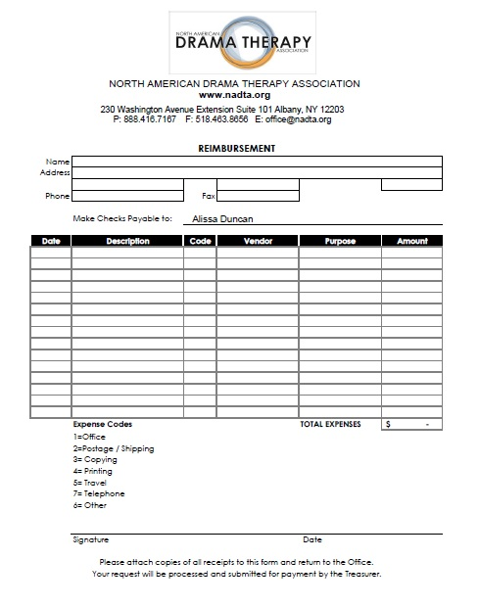

ONLINE RESOURCES FOR PROMOTING YOUR REGION

Promotion Resources

1. Any size Standing Banner/with Travel Tote
www.Signazon.com
Standing banner

2. Table logo and Table Runners w/Logo
www.4imprint.com
BestofSigns.com
www.TheEventhelper.com

